General Practice Home Delivery
Tool Kit

Intended Audiences:
- Hospital Manager: Resources for setting up automated home delivery
- Client: Client communications to inform and educate about home delivery service
What’s Included:
- Home Delivery Training
- Home Delivery Website Update
- Client Email Blast
- Script for after-hours/on hold messaging
- Social media posts and images
Additional Resources:
- Links to marketing content from Covetrus (Vet’s First Choice) and Vetsource via https://www.gpconnect.nva.com/
- Vetsource Quick Start Guide: http://pages.vetsource.com/Onboarding-Quick-Start.html

Covetrus
- Home Page Navigation Guide: https://covetrusrx.zendesk.com/hc/en-us/articles/360038807711-Home-Page-Navigation&utm_source=redirect
- How to Approve Scripts: https://covetrusrx.zendesk.com/hc/en-us/articles/360034559352-Approve-Pending-Client-Requests&utm_source=redirect
- How to Create a New Script: https://covetrusrx.zendesk.com/hc/en-us/articles/360034960991-Create-a-New-Prescription&utm_source=redirect\\
- Enabling Script Assist: https://covetrusrx.zendesk.com/hc/en-us/articles/360034576352
- Script Assist: https://covetrusrx.zendesk.com/hc/en-us/articles/360034958971-Script-Assist
How to Use:
- Training for HM’s on implementing and using home delivery service
- Email blast to introduce or remind clients of your hospital’s online pharmacy
- Social posts for Facebook and Instagram to share special offers and discounts with clients

1. HOME DELIVERY TRAINING
- After setting up an account, Vetsource and Covetrus will proactively reach out to the site to set up proper training for CSR and DVMs.
- Included in the training is setting up logins, integrating with PIMS, selecting the catalog, selecting their pricing preferences, marketing email settings, and going over how to approve and create scripts.

1A. VETSOURCE
- Vetsource will reach out to HM’s to schedule a training for you with their onboarding team. The onboarding trainers will take you through an easy-to-understand, live webinar training that covers important information like:
- How to place and approve an order
- How to proactively recommend products to pet owners
- Where to find important tools to support your Home Delivery program
- Additionally, Vetsource has provided a Quick Start Guide: http://pages.vetsource.com/Onboarding-Quick-Start.html with helpful tips once your live onboarding training is complete.
- If you need to contact Vetsource, you can reach them at onboarding@vetsource.com or call (877) 738-8883

1B. COVETRUS/VET’S FIRST CHOICE
- Covetrus will also proactively reach out to HM’s and staff to set up training. However, Covetrus provides several links with easy to follow instructions to navigate, set up, create and approve prescriptions.
- Additionally, Covetrus offer Script Assist, for automating your client’s prescriptions
- Links to all resources are below or scroll down for step-by-step instructions

- Home Page Navigation Guide: https://covetrusrx.zendesk.com/hc/en-us/articles/360038807711-Home-Page-Navigation&utm_source=redirect
- How to Approve Scripts: https://covetrusrx.zendesk.com/hc/en-us/articles/360034559352-Approve-Pending-Client-Requests&utm_source=redirect
- How to Create a New Script: https://covetrusrx.zendesk.com/hc/en-us/articles/360034960991-Create-a-New-Prescription&utm_source=redirect\\
- Enabling Script Assist: https://covetrusrx.zendesk.com/hc/en-us/articles/360034576352
- Script Assist: https://covetrusrx.zendesk.com/hc/en-us/articles/360034958971-Script-Assist

- To contact Covetrus 888-280-2221

NAVIGATING THE HOME PAGE
- All items that require your attention will display in this central location
- From here, you can Search for clients and products, see all your open tasks, add new clients and prescriptions, and navigate to other parts of the app. You can filter down the feed by using the search bar or toggling the filters. Expand a task to get more information and take action. Manage the Workflow Status for a task right from the feed.
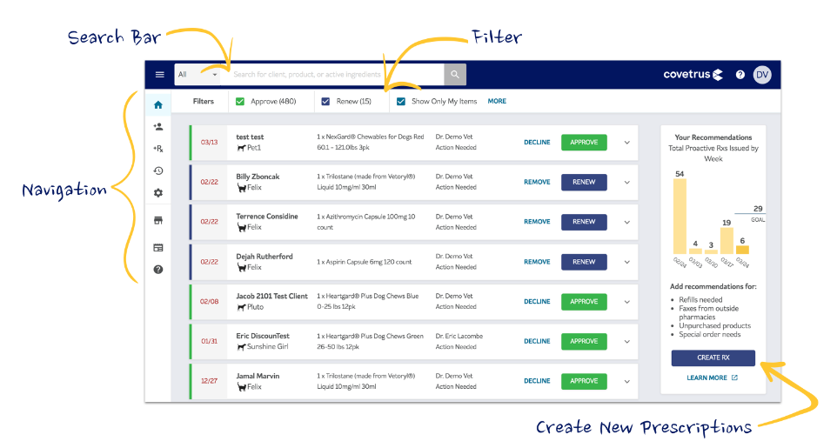

- To expand the navigation, click the three lines in the upper left corner
- The navigation is set up to remember your last state, so it will remain open until you close it or closed until you open it. It will retain its state across sessions
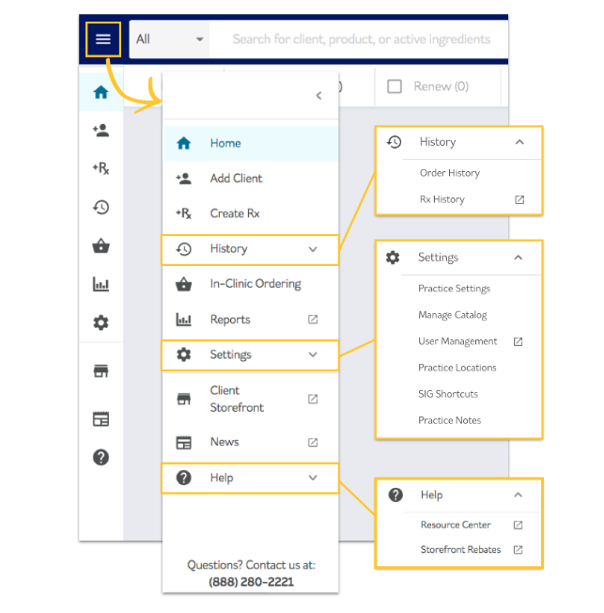

APPROVING PRESCRIPTIONS
Your clients are waiting for their order
- When a client places an order, we search the system for an existing prescription for each item. You will receive notice when we need your approval to fulfill. These requests show up in your feed as an approve feed item.
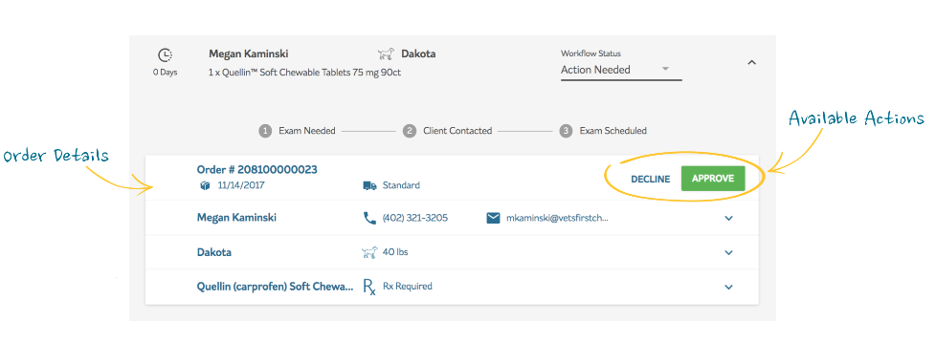
- Based on your permissions, you can Approve or Decline. Approve will expand the product card where you enter directions and authorize. If the client ordered the wrong product, you can Approve with Changes or Decline.
CREATING A NEW PRESCRIPTION
- Being proactive about prescribing helps ensure that your clients purchase medication from you.
- There are many instances where a client leaves the office without purchasing product. In these instances, use the platform to send a digital prescription to your client that they can order from later. Once you write the prescription, the client will receive an email and can click to order from your online store. The platform will provide you with visibility into whether or not they complied.

- Search for the client using the search bar at the top. If you are unable to find the client, you can add them manually by clicking on the orange "+" button. If you have a software system that communicates with Covetrus, you will be able to initiate a search and import the client from your software.
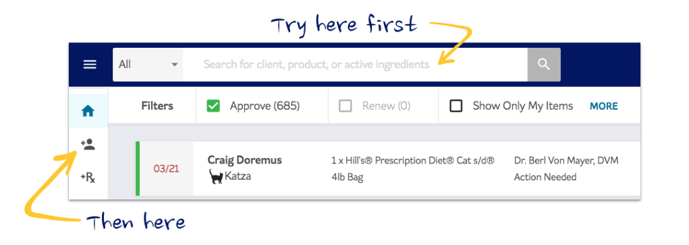

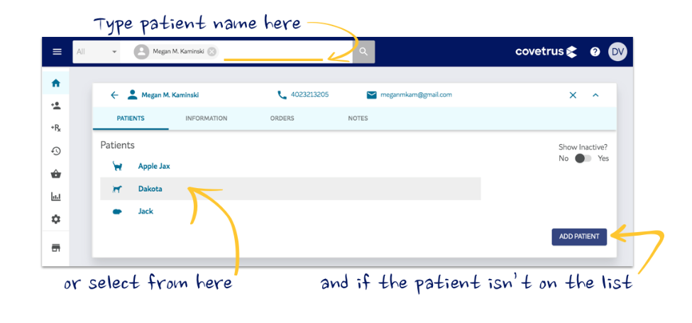
- Once you have the client selected, select the relevant patient by clicking his or her name or typing it next to the client name in the search bar above.

- To select a product, continue typing in the search bar or click the "+" button at the bottom of the page
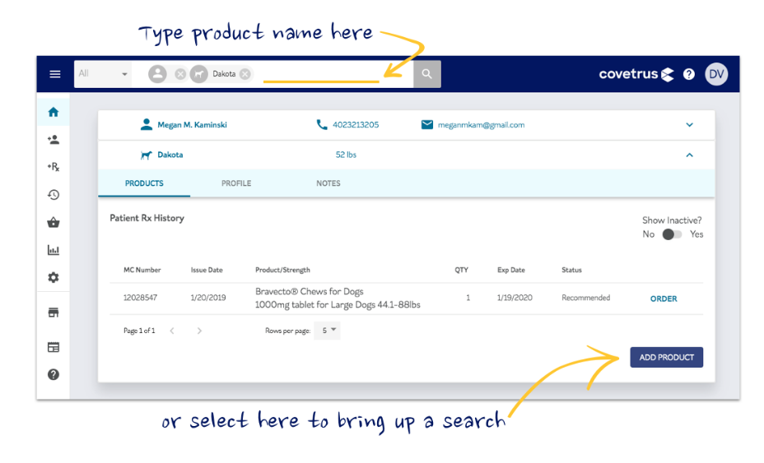

- For many products, the strength will default based on the weight of the animal. If you need to adjust anything, you can do so using the drop-down forms.
- The "Qty Authorized Per Fill" indicates how much product they can purchase at any one time. You can also authorize refills using the dropdown just below.
- Finally, add your directions by typing them manually into the "Directions" field or using a SIG shortcut.
- Once you have confirmed the information and added your directions, you can add any notes to the Pharmacy or Client. These will stay with the prescription until it expires.
- When you're ready, select the Authorizing Veterinarian and click the blue "Authorize" button to prescribe! Your client will receive an email notification sent on behalf of your practice momentarily, which will direct them to purchase this product on your store.
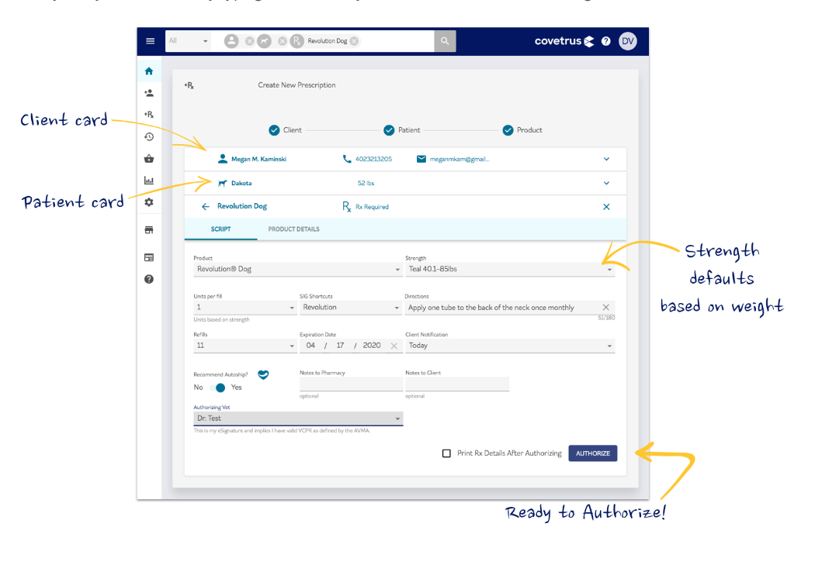

SETTING UP SCRIPT ASSIST (COVETRUS/VET’S FIRST CHOICE)
- Script Assist should be used as a tool to get clients and patients ‘back on track’ on their preventive therapies. If an appointment is canceled and they were due to purchase medication, be sure to pro-actively prescribe a medication for that client! If a client comes in for an exam and chooses not to purchase in hospital or online, a recommendation will appear within script assist so you can easily recommend something for them!
Follow the below steps to activate Script Assist within your Covetrus platform:
  - Log into practiceadmin.vetsfirstchoice.com (you must be a system administrator to do this)
    - Go to Practice Settings
    - Within Practice Settings, you will find a section labeled "Script Assist." Select "Edit" to continue.
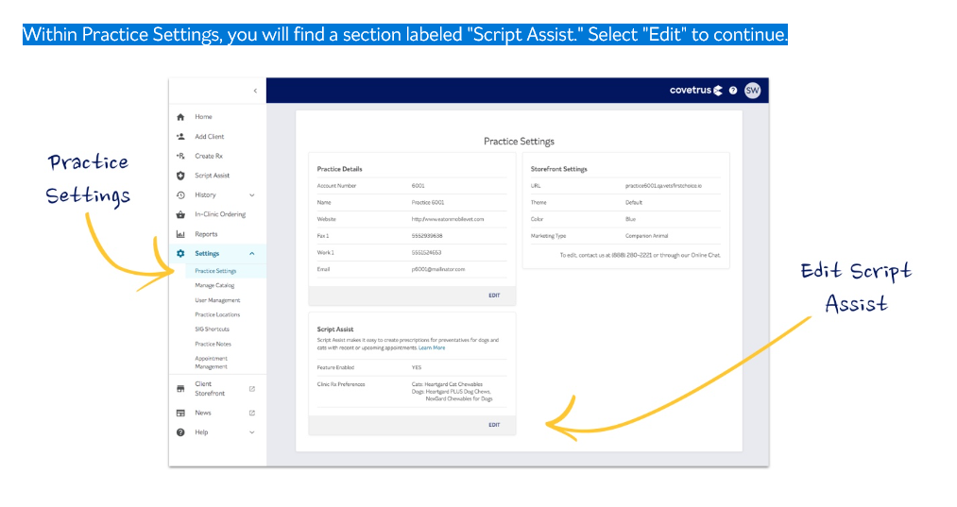

  - The "Feature Enabled" toggle allows you to turn the program on or off. When enabled, you will see "Script Assist" appear under Left Navigation. While disabled, the feature will be hidden from the menu.
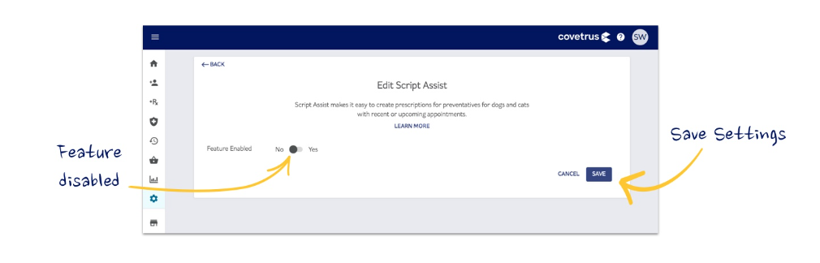

  - Once you've enabled Script Assist, you will need to add default preferences for results to appear. You can choose one default product per species per category. This will determine what appears as the pre-filled default, but you can always change the product as you issue each individual script, or return here to edit your defaults later.

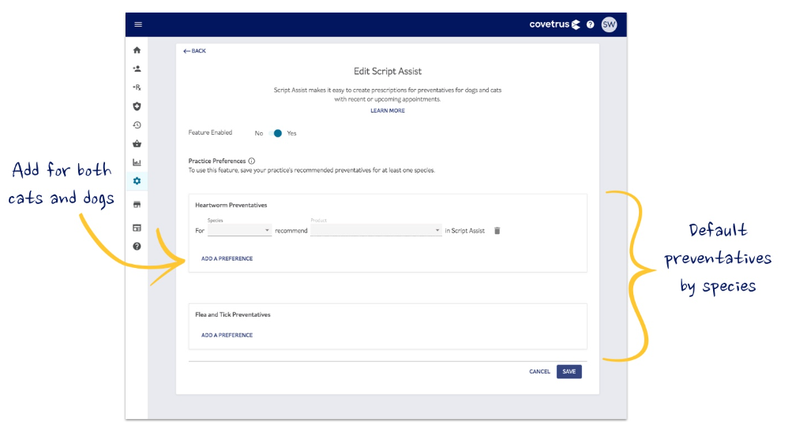
  - When you're ready, hit "Save" and navigate to Script Assist to begin processing recommendations!

UTLIZING SCRIPT ASSIST
- Once enabled, Script Assist provides your practice with an easy way to identify non-compliant patients and issue prescriptions.
- Using online store and practice prescription management system data, the system will look for patients who have a recent or upcoming appointment that have not purchased a preventative within the last 18 months.
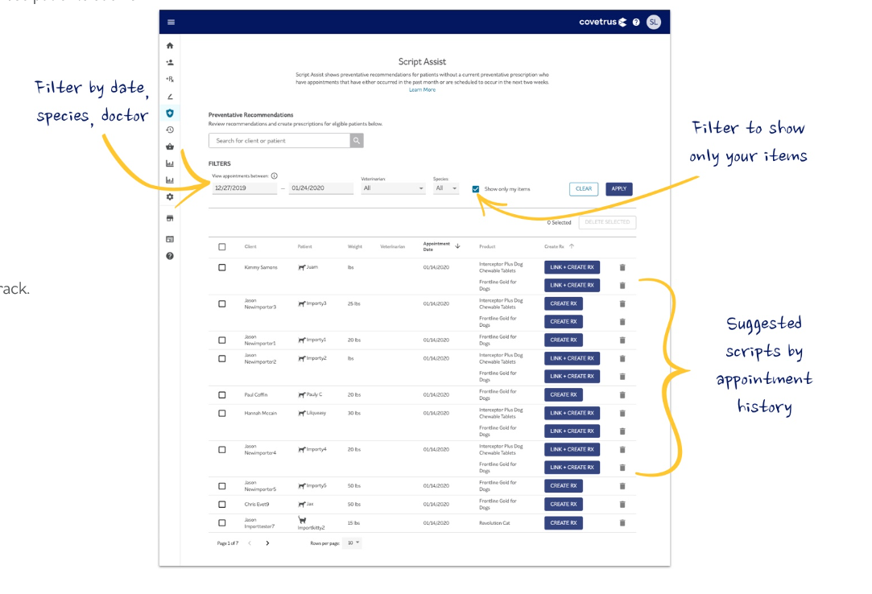
- It will then present you with a list of pre-filled prescriptions based on your product preferences, so you can get those patients back on track.
You will notice two types of actions in the feed:
- Create Rx will show for patients who have already been linked between your Covetrus Prescription and Practice Management Systems
- Link + Create Rx will show for patients for whom a link has not yet been established

Create Rx (Prescribe Through Script Assist - Linked Patients)
- To prescribe for a patient who has already been linked, simply select "Create Rx" to bring up the prescription pad.
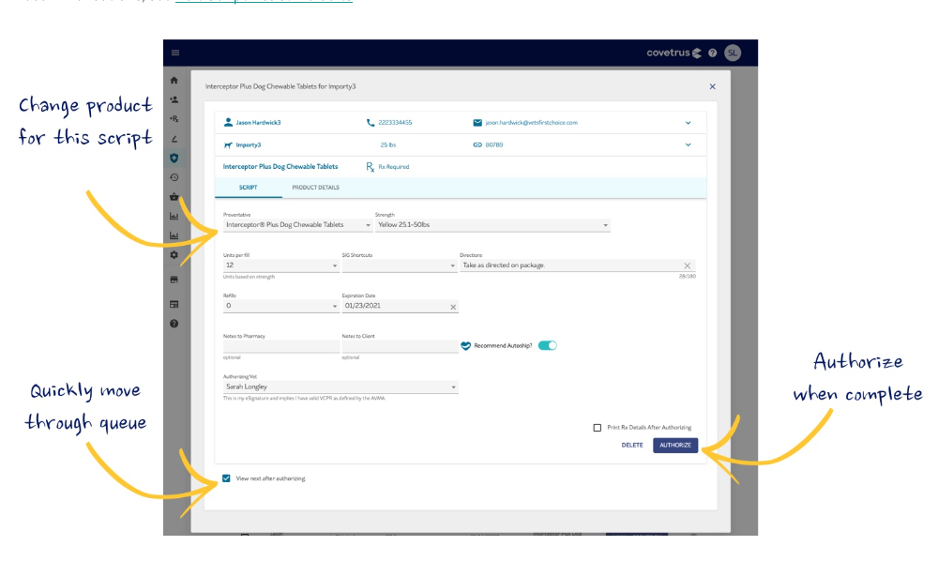
- The prescription will be pre-filled based on your defaults to make things easier, but you can change any field you need to before submission.

Link+Create RX (Prescribe Through Script Assist - Unlinked Patients)
- Script Assist results originate from appointment data within your Practice Management System. Because of this, it's possible that some patients will not yet have been imported into Covetrus. These patients will appear with the action "Link + Create Rx"
- The system will first attempt to match the patient to a client or patient with a similar name, phone number, or email address. If a match is found, simply select "Link Account" and then "Write Script" to continue the Create Rx flow.
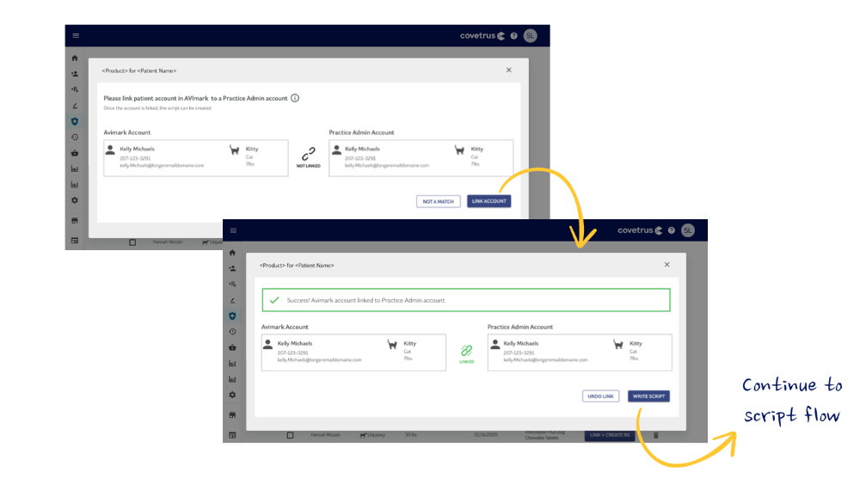
- In the event that an initial match is not found, you do still have the opportunity to search your Covetrus client base manually. This can be useful if the client associated with a patient may have a different last name, phone number, or email address than is associated with the medical record.
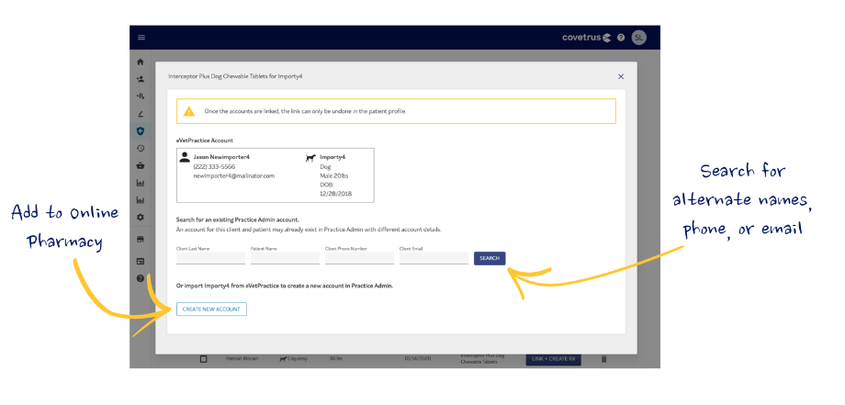
- If a match is still not found, select "Create New Account" to import the client to Covetrus and continue with your script

2. WEBSITE CONTENT
Hospitals on the NVA Platform:
- If you are on the NVA Website Platform, the following updates will be made to your hospital’s website automatically:

Third Party Website Vendors:
- If you are using a 3rd party vendor, we recommend the following updates be made to your website:
- Add the Vetsource or Vet’s First Choice link to your website (link can be supplied by Home Delivery partner).
- Create a section on your home page that prominently features home delivery and send the copy below to your vendor:
Copy:
We have a convenient Home Delivery service, so you can place orders and have food and medications delivered safely to your home. Click Here to Order!

Home delivery offers discounts and free shipping, in addition to automatic reoccurring shipments on some items, so you don’t need to worry about running out.

We partner with [Vetsource] or [Vet’s First Choice] a reliable Home Delivery program with veterinary-trained pharmacists on staff. Our trusted partner follows CDC safety guidelines and all the necessary precautions to ensure orders are delivered as safely and quickly as possible.

3. EMAIL BLAST TO CLIENTS
- To introduce your clients to home delivery, below is a customizable Email blast to educate and inform clients that your hospital now offers / does offer Home Delivery. Choose from the banners below to use with your email blast

- If you use AllyDVM, this email communication and banners have been loaded into your dashboard already and you can send the communication when ready.
- If you use Vetstreet and you don’t have log-in access and wish to send an eblast, contact the below individuals to help you set up your campaign:
  - support@vetstreet.com
- If you use PetDesk and need help setting up a campaign, contact the below individuals:
  - Kayla Hanono (kayla@petdesk.com) or Mackenzie Baird (mackenzie@petdesk.com)
- If you use any other client communication platform, use the email template above and contact your specific vendor for help, where needed.

Dear Friends and Family:
Subject: Visit Our Online Store!
[Existing home delivery service]
Home delivery of medications and food.
Now, more than ever, we want to assure you that our hospital is open, and remains an essential service. Our doctors and staff continue to provide care for your pets, and we understand that many of you are concerned about being able to get your pet’s food, medications, and other items. We want to make sure you know that we do offer Home Delivery service, so you can place orders and have food and medications delivered safely to your home. [add link to your practice’s online store]
[Newly added online pharmacy service]
Home delivery of medications and food.
Now, more than ever, we want to assure you that our hospital is open, and remains an essential service. Our doctors and staff continue to provide care for your pets, and we understand that many of you are concerned about being able to get your pet’s food, medications, and other items. We now offer a Home Delivery service, so you can place orders and have food and medications delivered safely to your home. [add link to your practice’s online store]
Trusted partners in pet health.
We partner with [Vetsource] or [Vet’s First Choice] a reliable Home Delivery program with veterinary-trained pharmacists on staff. Our trusted partner follows CDC safety guidelines and all the necessary precautions to ensure orders are delivered as safely and quickly as possible. This includes conducting frequent deep cleanings and daily sanitizing of all work areas. They’re also working closely with manufacturers and other partners to increase inventory and ensure timely delivery.

Shop and save!
Home delivery offers discounts and free shipping, in addition to automatic reoccurring shipments on some items, so you don’t need to worry about running out.

Home delivery, keep your pets healthy and happy
Our doctors and staff are committed to pet wellness, and we are proud to offer a safe and convenient way to ensure and ensure your pet gets what they need to stay healthy and happy. Please don’t hesitate to reach out if you have any questions or concerns.

Sincerely,

4. ON HOLD AND AFTER HOURS MESSAGING
- See below sample on hold messaging that you could use in your practice.

We offer [now offer] home delivery for all your pet’s pharmacy and prescription diet needs! Visit our online store at [insert hospital website] and click on pharmacy. Already using our online store? Ask us about enrolling in auto script and never worry about running out of your pet’s medication again!

5. SOCIAL MEDIA POSTS
- Both Vetsource and Vet’s First Choice provide a variety of social media content to promote online pharmacy. All social media content is updated monthly and can be found on https://www.gpconnect.nva.com/

Vetsource

Social Posts | Graphic
Shop and save with our online store, so you can have your pet’s medication and food delivered safely and conveniently to your home. Free shipping on most items! [add link to your practice’s store]
If you need pet needs food and medication, shop our online store and save! Discounts and free shipping on most items! [add link to your practice’s store]

It is Flea, Tick and Heartworm season! To make sure your pet is protected, visit our online store to purchase your pet’s preventative! Most items qualify for free shipping and you can set the deliveries on AutoShip so you don’t have to worry about running out. [add link to your practice’s store]
If your pet needs any food or medications, we want to make sure you know about our online store and home delivery. You can have these items shipped directly to your home, often with no shipping costs. Additional steps have been taken to ensure we are able to ship your orders safely and securely. [add link to your practice’s store]

Vet’s First Choice/Covetrus

Social Post | Graphic
Shop online and save! Visit our online pharmacy to receive discounts off your pet’s food and medicine! [add link to your practice’s store]
If you need pet food and medication, we want to make sure you know about our online store that ships these items directly to your door. [add link to your practice’s store]

It is Flea, Tick and Heartworm season! Make sure you pet has year round prevention! Shop our online store for medications that protect your pet from infection! [add link to your practice’s store] | 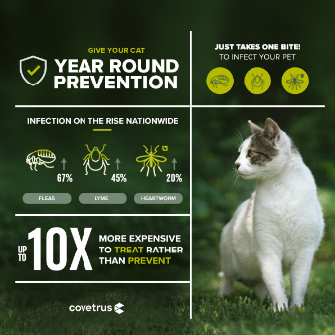
You can be sure your pet’s food and medication ships from a safe and reliable source. Visit [add link to your practice’s store]

