FACEBOOK GUIDE
FACEBOOK GUIDE
WHEN YOU SHOULD USE GUIDE:

Upload a post to Facebook
Schedule a post in advance
Pin a post at the top of your timeline
Change your Facebook cover page

INSTRUCTIONS TO UPLOAD A POST TO FACEBOOK
- Step 1: Log into your Facebook hospital page and you will land on the Home
- Step 2: From your Home page, locate Create a Post section below the hospital image

- Step 3: Type your message. Facebook recommends creating a brief message no more than 1-2 paragraphs long.
- Step 4: Upload a photo/video. Locate the photo you wish to upload on your desktop or in a folder. Once you are done uploading the image, click on POST. Your Facebook post will be visible in a few seconds.

INSTRUCTIONS TO SCHEDULE A POST IN ADVANCE
Step 1: Go to your Facebook page as if you were going to post something right now. Once there, click on “Creator Studio” link
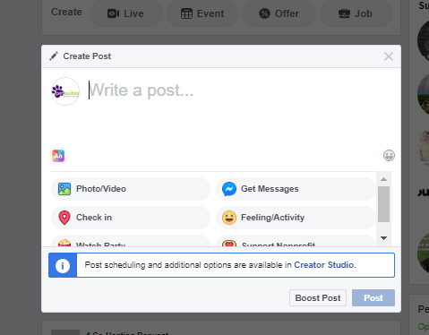

Step 2: Once in Creator Studio, you should automatically be on the FB tab. You can click on “Create Post” in the top left corner. Once there, click on “Create Post” again in the dropdown
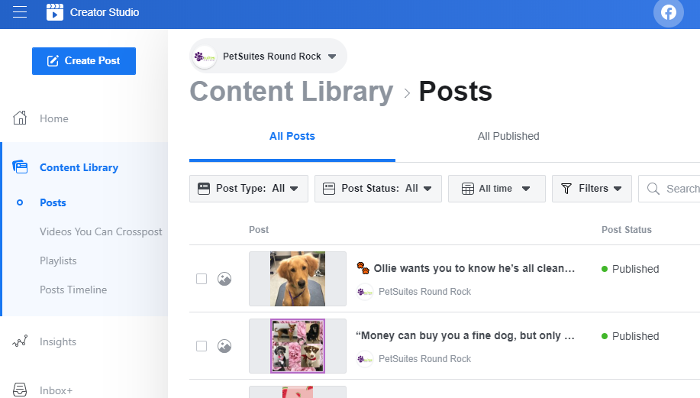

Step 3: Create your post and include any pictures/videos/feelings/etc. as you would normally. Then, click on the down arrow next to the publish button and choose when you want your content to post
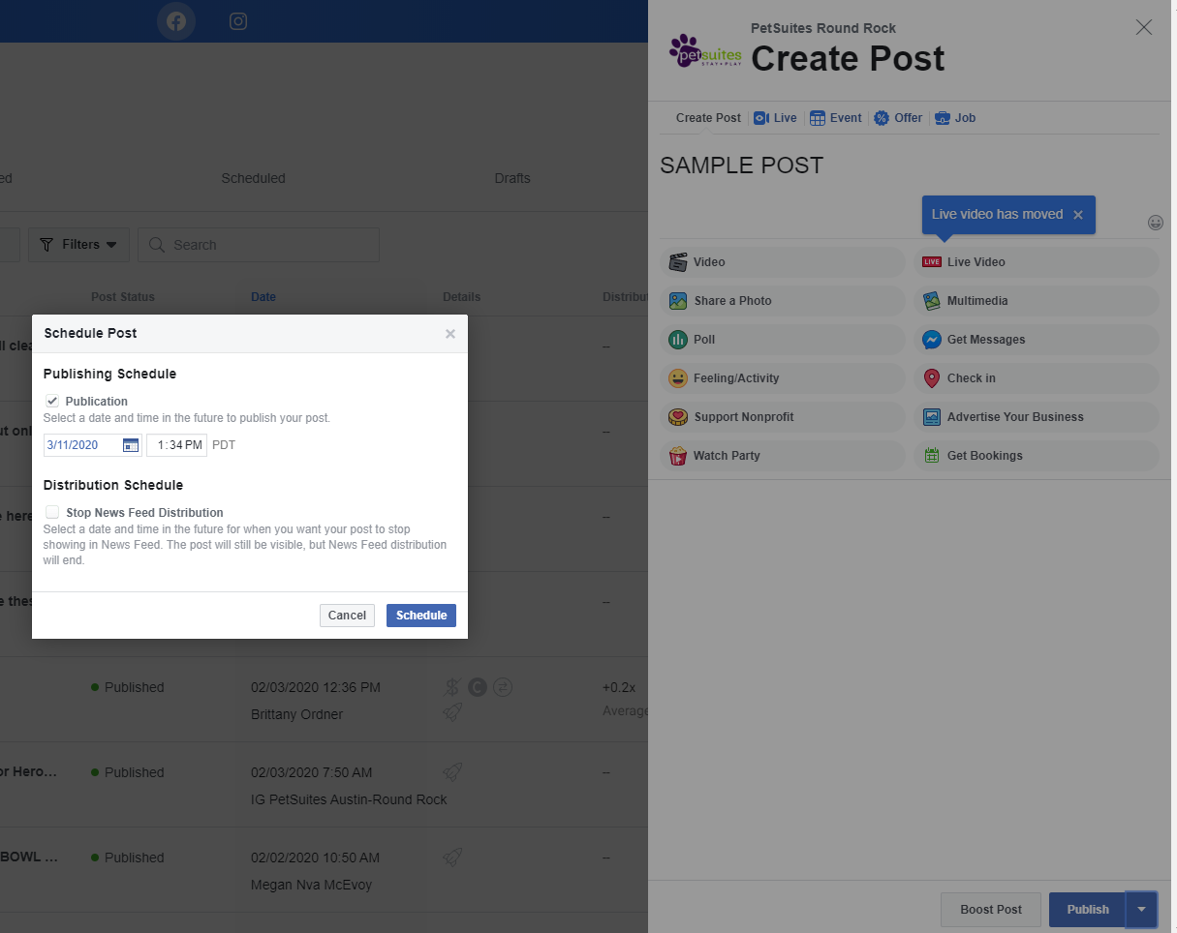
Step 4: From there, click schedule and you’ll be good to go!
Step 5: To check on scheduled posts, go to Content Library (left vertical navigation bar) and click on scheduled, which is a column on the top
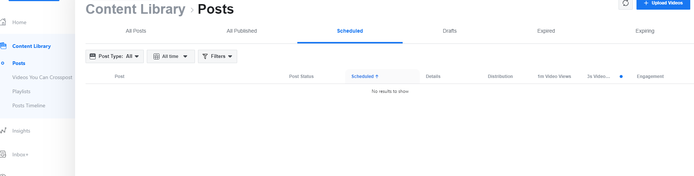

Step 6: To switch from Facebook to Instagram, you simply click on the Instagram icon in the top center of the page
Step 7: From there, you will upload your creative asset and write the caption. When posting on Instagram, you can also choose to schedule it to Facebook (two birds, one stone!). Follow the same instructions for scheduling by using the down arrow next to the publish button, choose the date and time.

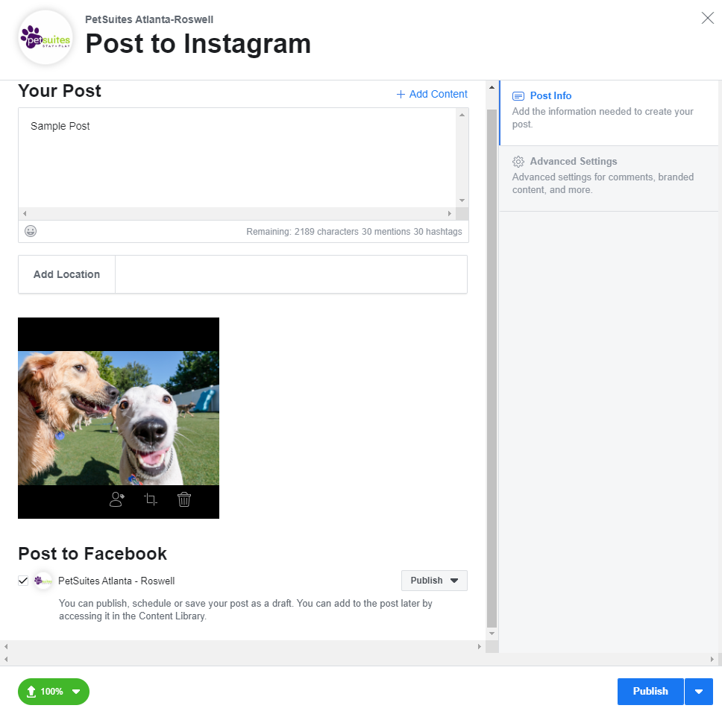

INSTRUCTIONS TO PIN A POST AT THE TOP OF THE TIMELINE
- Benefits of pinning a post:
  - Post stays at the top of the Timeline for 7 days, without slipping down as the hospital uploads more posts
  - It allows your practice to drive visibility towards key posts such as COVID-19 updates
  - Pinned posts get more visibility than regular posts
- What you need to know:
  - A pinned post is located at the top of your Facebook Timeline
  - Only 1 post can be pinned at any given time.
  - A pinned post will stay at the top of the Timeline for 7 days. If you want the post to be pinned at the top for longer periods of time, you will need to pin the post again after initial 7-day period.
Steps by step instructions to pin a post
- Step 1: Log into your Facebook hospital page
- Step 2: Select POSTS from the left hand side of the navigation menu

- Step 3: Find the post you wish to pin to the top of your page.

- Step 4: Click on the 3 dots (right hand side of the post) and select “Pin to Top of Page”.

INSTRUCTIONS TO CHANGE FACEBOOK COVER PAGE
- What is a Facebook cover photo? A cover photo is the larger photo at the top of your profile, above your profile picture. Like your profile picture, cover photos are public, which means anyone visiting your profile will be able to see them.
- Steps by step instructions to change the cover page
Step 1: From your News Feed, click your name in the top left corner.
Step 2: Hover over Update Cover Photo in the top left of your current cover photo.
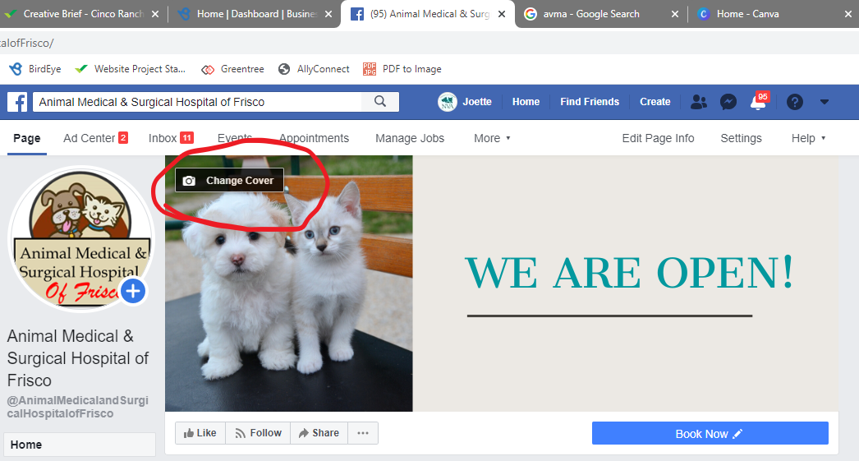

Step 3: Click Update Cover Photo. If you don't currently have a cover photo, click Add Cover Photo.
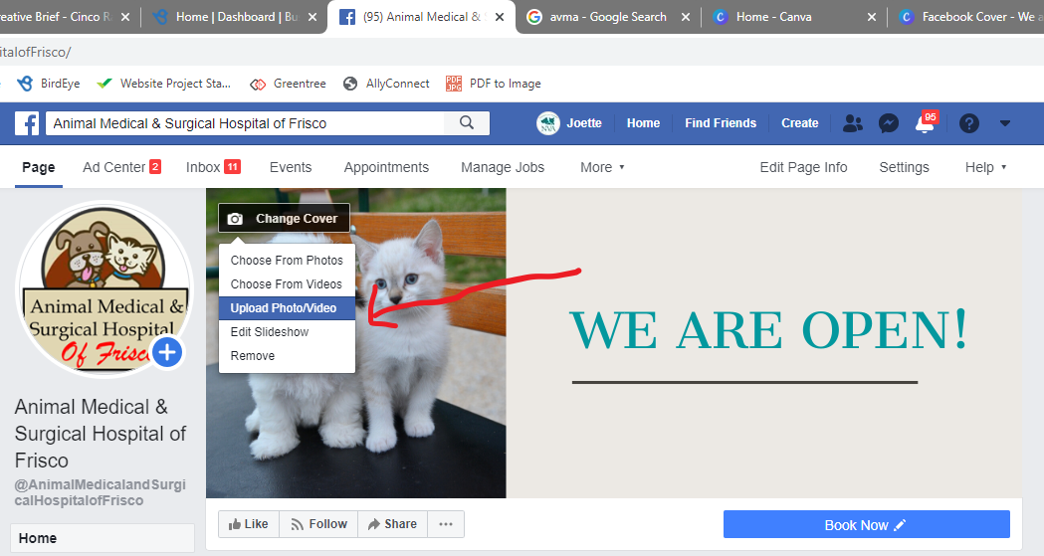

Step 4: Click Upload Photo... to upload a new photo from your computer, Select Photo to pick a photo from one of your Facebook albums, Create a Collage or Select Artwork.
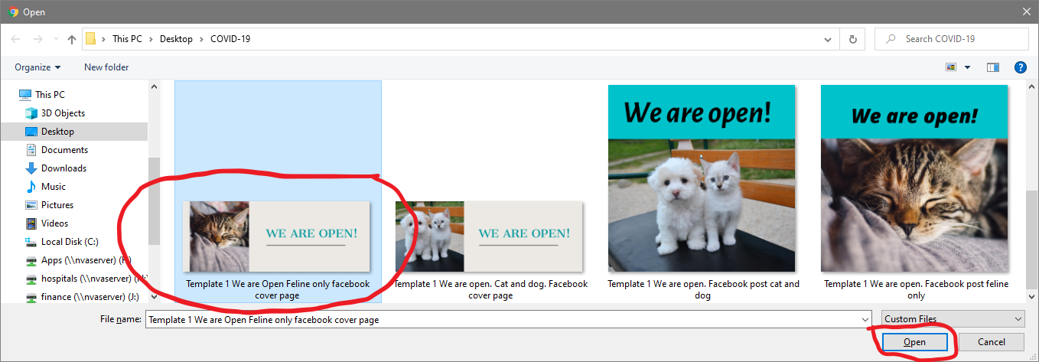

How to Pin a Post
Step 5: Once you choose a photo, you can reposition it by clicking the image and dragging it up or down.
Step 6: Click Save Changes.

