Heatwave & Heatstroke Awareness Toolkit

WHEN YOU SHOULD USE THIS TOOL KIT:
YES | You want to educate clients about dangers of heatstroke in pets during high temperatures
YES | You want to provide list of symptoms to watch for and what to do in an emergency

WHY LAUNCH THIS CAMPAIGN?
Many of our hospitals are located in areas that are prone to extremely high temperatures, especially during the Summer months. With record-setting temperatures occurring every year, we want to provide you with social posts to help educate clients on best practices during excessive heatwaves and possible signs of heatstroke in your pet. Educational social media posts and email communication can not only create engagement with pet owners, but also boost loyalty to your clinic and save a pet’s life!

WHAT IS INCLUDED IN THIS TOOL KIT?
- Variations of heatwave/heatstroke awareness social media posts and graphics
- Signs of heatstroke flyer/poster
- Heatwave & heatstroke email messaging

HOW TO USE IT
- Send an educational email to pet parents during the summer months, increasing heatwave and heatstroke awareness; share social media posts to clients.

- SOCIAL MEDIA COPY
Education Posts (11 Posts, 12 Graphics)

- Social media is one of the best ways to educate pet parents on pet wellness including the dangers of heatwaves and heatstrokes in pets.
- Please review the below recommended posts and select the ones that suit your clinic’s needs. Feel free to customize them, if needed.
- Wednesday is a good day to upload educational information for pet parents as part of the #Wellnesswednesday series.
- Full-size, his-res versions of the social media graphics are available for download on the https://www.gpconnect.nva.com/ website. The password is woof2020.

Graphic/Other Content | Post Copy
Post Graphic: Education 1  Paw pads on hot ground | Pavement can sometimes get 40-60 degrees hotter than the outside temperature, which can cause extreme damage and pain in your pet’s paw pads. Be cautious of the ground when walking your pet on a warm day. TIP: If you can’t hold your own hand on the pavement for 10 seconds then the ground is too hot for your pet!  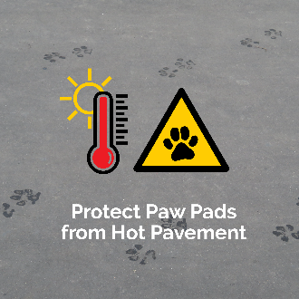
Post Graphic: Education 2  Do not leave pets in vehicles 1 | The inside temperature of your car can raise 20 degrees in just 10 minutes and over 30 degrees in just 30 minutes! Never leave your pet alone in your car on a warm day!  CALL [CLINIC TEL NUMBER] immediately if you think your dog may have been left in a car for too long and needs attention.  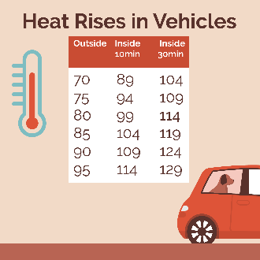
Post Graphic: Education 3  Do not leave pets in vehicles 2 | NEVER leave your pet alone in a warm vehicle. Temperatures inside your car can climb exponentially fast especially in the Summer. Dogs can experience heatstroke and even death in under 15 minutes of being inside of a hot vehicle.  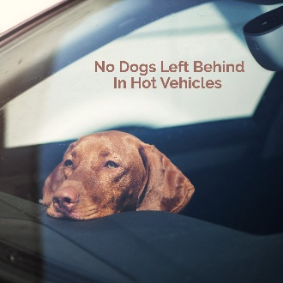
Post Graphic: Education 4  Causes of heatstroke in pets | Know the common causes of heatstroke in pets.  CALL [HOSPITAL TEL NUMBER] immediately if you think your pet may be experiencing a heatstroke or other emergency.  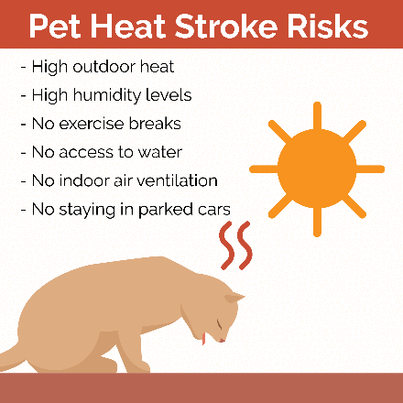
Post Graphic: Education 5  Symptoms of heatstroke in pets | Pets get heatstroke too! Watch out for excessive panting, high heart rate, vomiting or diarrhea, bright red gums, body temp over 104 degrees, collapses or seizures. Think your pet is having a heatstroke? Pour cool water on your pet until their breathing settles – but don’t let them shiver - and call your vet right away for guidance.  CALL [HOSPITAL TEL NUMBER] IMMEDIATELY if you think your pet is experiencing a heatstroke.  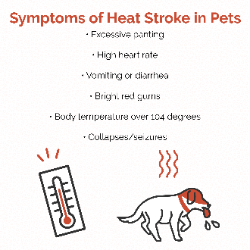
Post Graphic: Education 6  What to do if your pet has a heatstroke | If you think that your pet is having a heatstroke move them to a cool, shaded area, immediately pour cool (not cold) water over them or use a wet towel to cool them down, have them drink cold water, continue to pour cool water over them until their breathing settles, and then CALL [HOSPITAL TEL NUMBER] IMMEDIATELY as this will be an urgent matter.  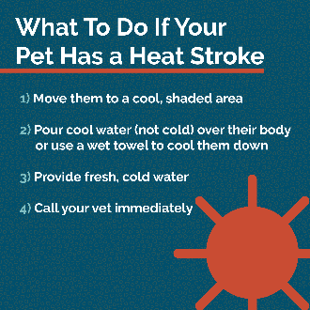
Post Graphic: Education 7  Heatwave awareness | Keep pets cool when it’s hot out! Make sure pets have shade and cool water. Watch for signs of heatstroke, like excessive panting and vomiting. Never leave pets alone in hot cars – even on a cloudy day, they can overheat!  CALL [HOSPITAL TEL NUMBER] TODAY to learn more about the safety steps that you can take for your pet during an excessive heatwave.  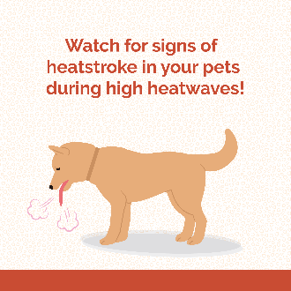
Post Graphic: Education 8  Keep your pets cool | Always remember to keep your pets cool during Summer months and excessive heatwaves!  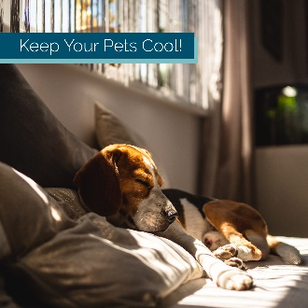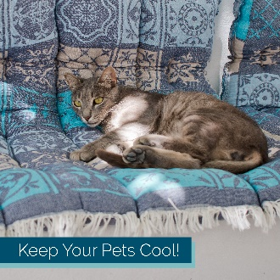
Post Graphic: Education 9  Sunburn protection for dogs | Did you know that dogs can get sunburns and other affiliated diseases when exposed to the sun like we can? Safety measures such as applying pet sunscreen on your dog can drastically lower the risk of sun-related complications.  CALL [HOSPITAL TEL NUMBER] TODAY to learn more.  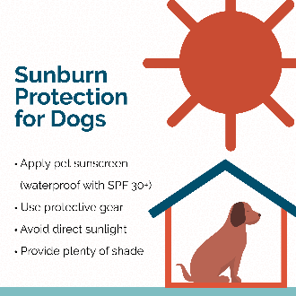
Post Graphic: Education 10  How much water does your pet need? | Most dogs require about 1 ounce of fluids per pound per day to be properly hydrated. Highly active dogs and puppies generally drink more water, but if you think that your dog isn’t drinking enough OR drinking too much call [HOSPITAL TEL NUMBER] as it may be due to an underlying health problem.  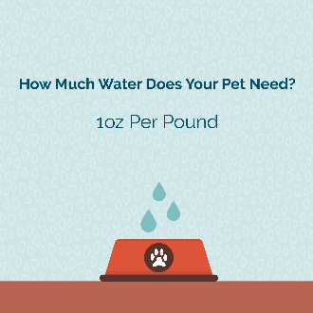
Post Graphic: Education 11  National Pet Fire Safety Day | Brush fires and evacuations are common during high heatwaves. National Pet Fire Safety Day is July 15th this year, and it is a great time to review your fire safety plans with your family to keep them and your pet safe in case of an emergency.  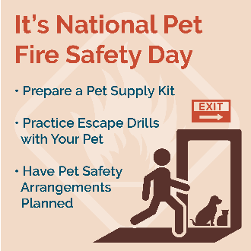

- Signs of Heatstroke in Pets Flyer
- During the Summer season print and post the below flyer(s) to increase awareness of symptoms of heatstroke in pets.
- The flyers can be downloaded from https://www.gpconnect.nva.com/ website. The password is woof2020.

General
In Memory of Lilly

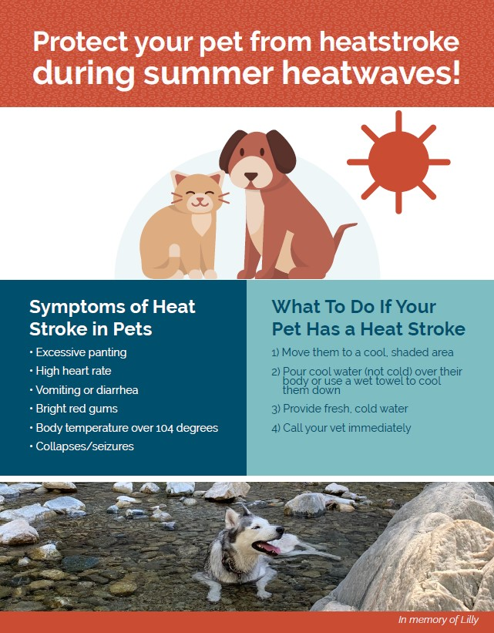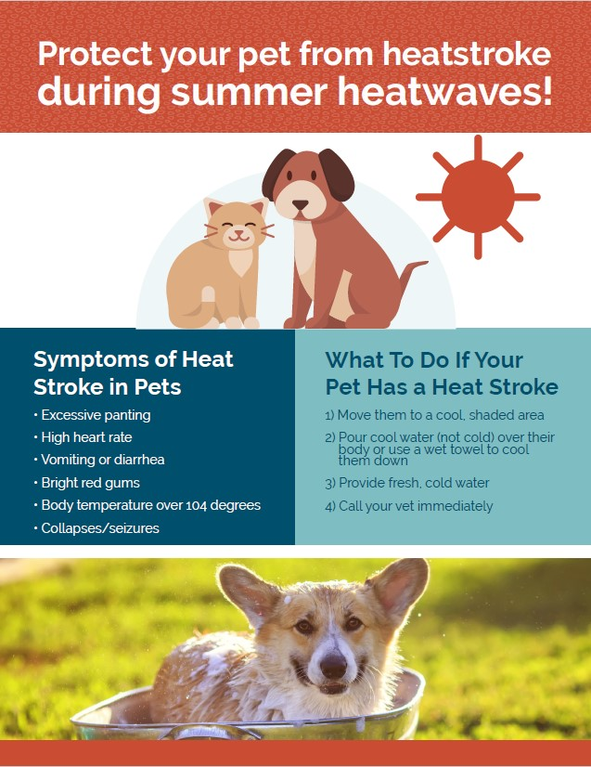

- EMAIL MESSAGING
- To inform your clients on what to watch for during a heatwave and high-temperature days, including signs and symptoms of a heatstroke. Choose one of the email banners below when sending your eblast.

Protect your pet from heatstroke!
Protect your pet during summer heatwaves!

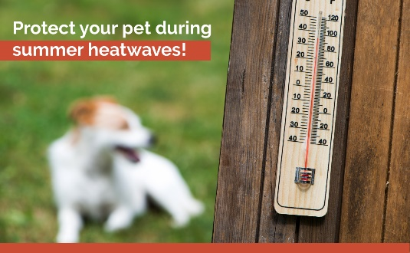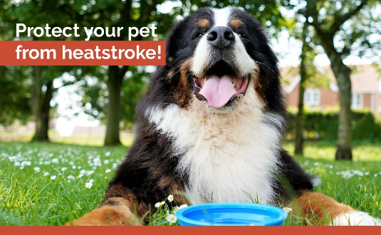

- If you use Vetstreet and need help obtaining log-in credentials or setting up the eblast, contact support@vetstreet.com
- If you use AllyDVM and need help obtaining log-in credentials or setting up the eblast in the dashboard, send select the NVA AllyDVM distribution list in Outlook and send an email using your NVA email account.
- If you use PetDesk and need help setting up this campaign, contact Kayla Hanono (kayla@petdesk.com) or Mackenzie Baird (mackenzie@petdesk.com)
- If you wish to send this communication directly from AVImark, instructions are attached.

- If you use any other client communication platform, use the email template above and contact your specific vendor for help, where needed.

EMAIL TEMPLATE:

Subject line: Protect your pets against heatstroke during summer heatwaves!

Dear Clients,

The hot weather is back for the summer, and with it the chance that a pet you love could suffer from heatstroke.
Keep an eye out for these heatstroke warning signs:

- Excessive panting
- Vomiting
- Collapse
- Seizure
- Bright Red gums
- Over 104 body temperature
- Diarrhea

Ways to keep your pet cool during a heatwave:
- Make sure pets have shade or keep them indoors
- Offer cool water for them to sip in small amounts
- Never leave pets alone in a car – even on cloudy days, cars can overheat

The Staff at <HOSPITAL NAME>

