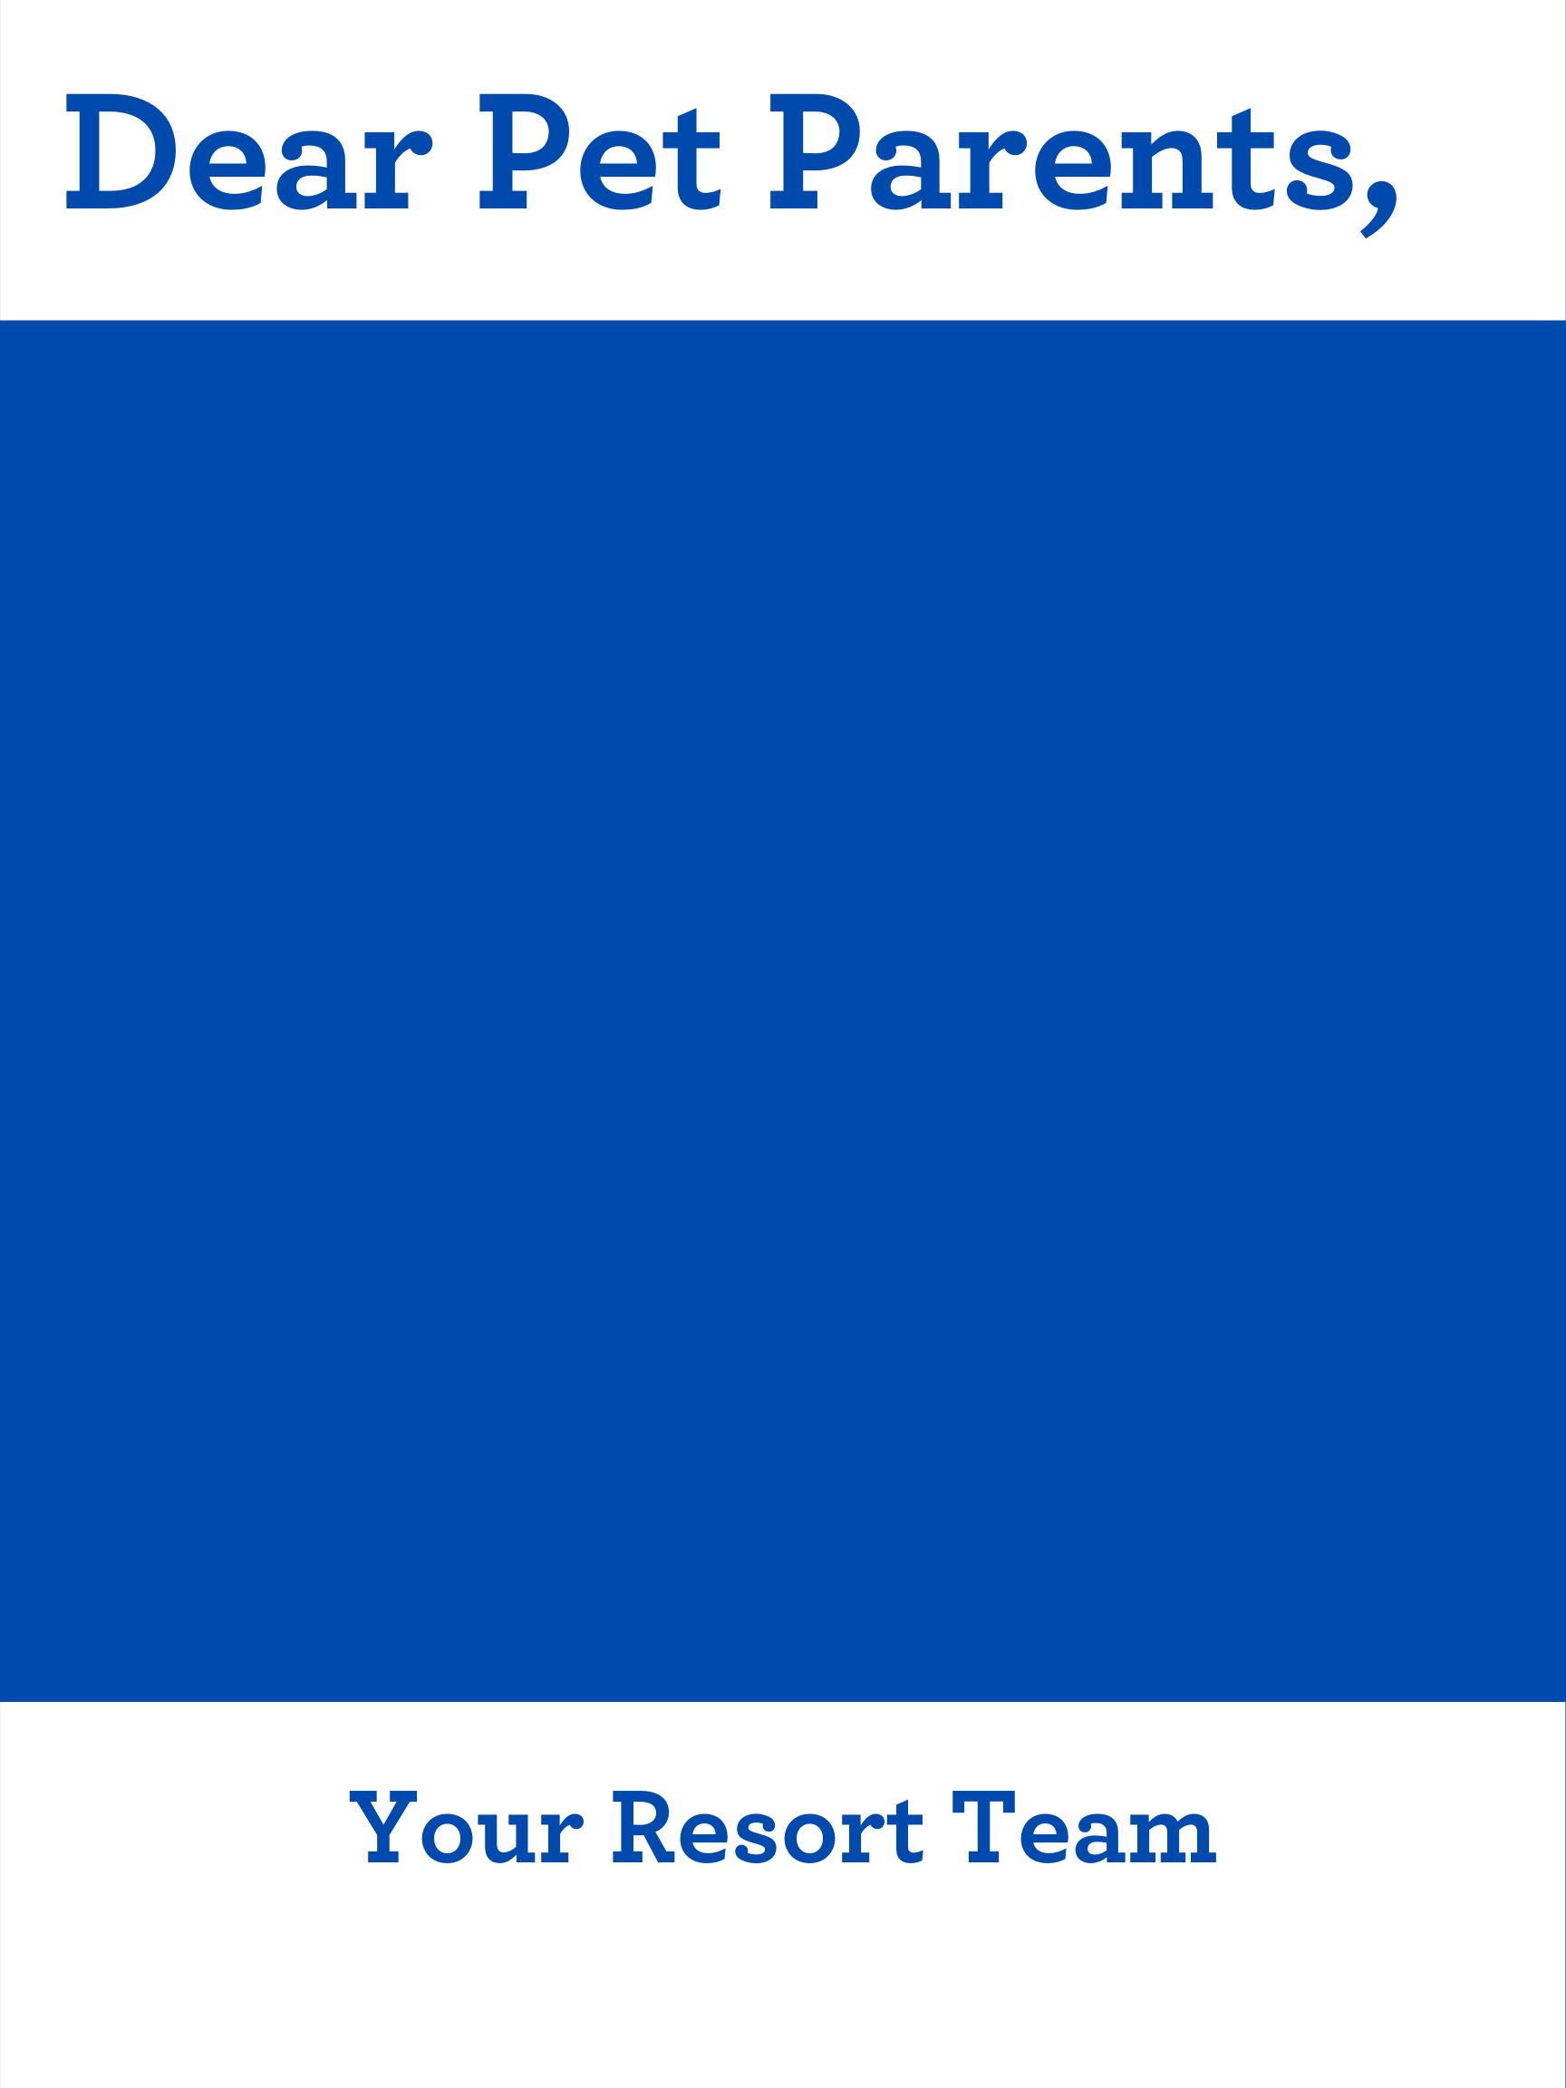S

**DEAR PET PARENTS,**

**WE ARE OPEN BUT ARE RESTRICTING ACCESS TO OUR LOBBY and adjusting our check-in and checkout procedures.**

**Please follow the steps below for the safety of all:**

* **If you are healthy and have an appointment, upon arrival at our clinic, PLEASE REMAIN IN YOUR VEHICLE OR OUTSIDE THE CLINIC AND CALL US.**
* **After receipt of the call we will check in your pet as soon as possible from outside of the clinic.**
* **PLEASE REMAIN IN YOUR VEHICLE during the entire time your pet is receiving medical care at our facility.**
* **If you need to pick up food or medication, PLEASE REMAIN IN YOUR VEHICLE OR OUTSIDE THE CLINIC AND CALL US.**
* **If you are feeling ill and your pet requires medical care, please CALL [ENTER TELEPHONE NUMBER] to discuss.**

**HOSPITAL NAME**