How to add a “Shop” tab in Facebook

WHEN SHOULD YOU USE THIS TOOL KIT?

YES | You want to add a “Shop” tab to your Facebook page
YES | You have an online store
YES | You offer home delivery

WHY ADD A “SHOP” TAB?
While we strongly suggest that your Facebook page is mainly used for driving business through visits via an appointment button and by driving traffic to your website, we understand if you’d like to add the “Shop” tab to your page as well. We’ve put together some simple instructions for adding the tab to your Facebook page so clients can access your online store through there, and not just your website.

HOW TO ADD THE “SHOP” TAB
Please follow the steps below for adding a Shop tab to your Facebook page.

Adding the Shop tab to your Facebook page:

- View your Facebook page from a desktop web browser. Click the “Shop” tab from the left-hand menu.
  - If you do not see a “Shop” option, click Edit Page Info → Templates and Tabs, and add the “Shop” tab.
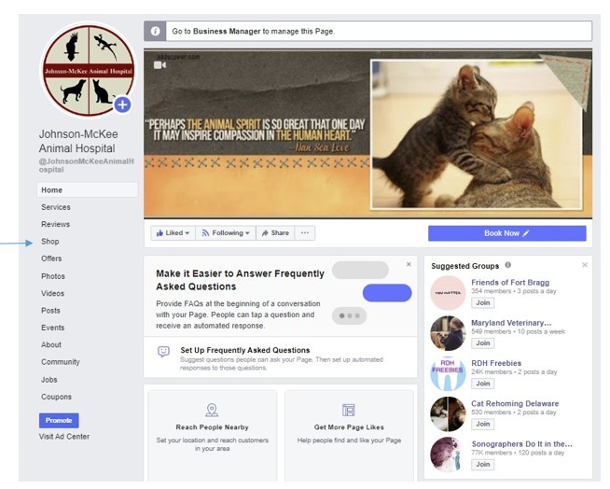
- Click “Go to Commerce Manager”.
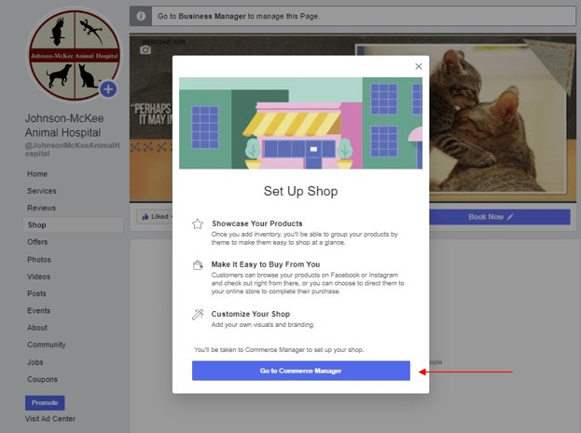
- Select where you would like your clients to complete their purchase.

  - Your Website: Customers will be directed to your website from your item’s details page. Customers will be able to browser your shop on Facebook or Instagram. On an item’s details page, they’ll have the option to go to your website to view more information or checkout.
  - Checkout on Facebook or Instagram: Customers will be directed to in-app checkout form your item’s details page. Customers will be able to browser your shop and checkout directly on Facebook or Instagram with Facebook Pay. They won’t be directed to your website. Your business will manage orders here in Commerce Manager or on a partner platform, such as Shopify. You’ll need to provide details about your business for payouts and taxation.
  - Direct Messsage: Customers will be directed to start a chat from your item’s details page. Customers will have the option to message your business from an item’s details page. They’ll be able to browse items on your Page or profile shop, but they won’t be directed to in-app checkout or your website.

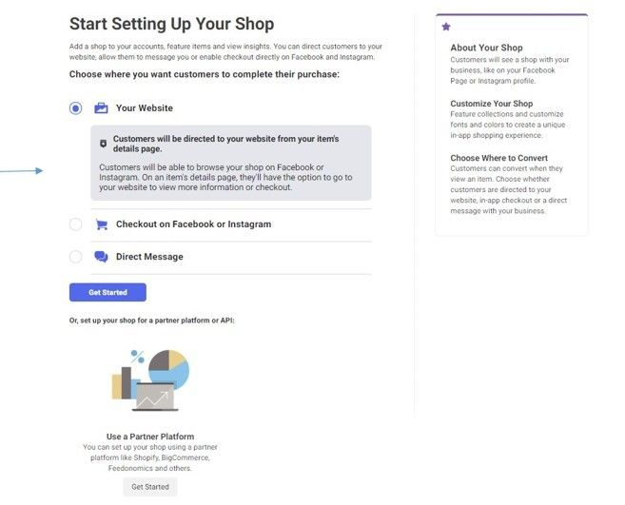

- Once your Facebook Page shop is set up, your next step is to create a catalog of your products.

- After you get set up with your Facebook Page shop, you can use Commerce Manager to manage sales across Facebook and Instagram. Products from your Facebook Page shop may appear in Marketplace if they're eligible.

