FIRST RESPONDERS GP MARKETING KIT

WHEN YOU SHOULD USE THIS TOOL KIT:

YES | You want to increase visits in April and May 2020
YES | You wish to show appreciation for the local first responders during COVID-19 pandemic (medical, law enforcement and fire fighters)

WHY LAUNCH THIS CAMPAIGN?
Many businesses offer discounts and promotions to first responders during COVID-19 to show their gratitude for continuing to work during this pandemic. Following this approach could help deepen the relationship with the community and generate new clients in the process.

HOW CAN YOU SHOW APPRECIATION?

There are several ways your clinic can show appreciation for first responders post COVID-19 pandemic:
- Offer early and late appointments, where available, within your reduced staffing model.
- Offer drop off appointments (pet remaining at the clinic for the day if kennels are available)
- Offer same day appointment, where available.
- If your hospital has PAW Plans, offer to waive enrollment membership fee ($49.95 Value!)
- Offer a discount off exams during April and May 2020
  - The discount offered can be customized by your practice and must be agreed upon with your hospital and operational leadership (DL or MRO).
  - If existing customers are first responders, the recommendation is to offer them between 10%-15% off all exams during April and May 2020. This campaign can be extended beyond May, if needed.
    - Remember to add a discount code in your PIM system to track the campaign results.
  - If the first responders are new clients, you can offer them your new client offer (i.e. 50% off first wellness exam or FREE exam) instead of the 10%-15% off discount.

WHAT IS INCLUDED IN THIS TOOL KIT?
- Email:
  - Email banners, communication template, and instructions to send eblasts
- Website messaging
- Facebook (social media banner, posts, instructions to post on Facebook)
- Flyers
- Local marketing checklist

1. EMAIL TEMPLATE

Please review the below communication to make it relevant for your practice. We recommend that you add, remove or edit this template, where needed.

Subject line: Deepest gratitude to first responders

Dear Clients,

During this challenging time, we want to express our gratitude for all the local medical personnel and first responders who are keeping our communities safe.

As a way to show our appreciation we are offering the following to all first responders and medical personnel:

- xx% discount off exams in April and May
- Same day appointments (as available) If you call us in the morning, we will try to fit you in
- Ask about flexible drop off and pick up times
- Waive PAW Plan membership fee (if your hospital offers PAW Plans)

If you know a pet parent who is a first responder, doctor or nurse, please let them know we would love to care for their family. First responders can BOOK AN ONLINE APPOINTMENT at <<ENTER URL>> or CALL <<ENTER PRACTICE TELEPHONE NUMBER>>. A first responder valid ID is required to verify employment status when checking in.

Thank you and look forward to seeing you and your pet soon!

The Staff at <<HOSPITAL NAME>>

ADDITIONAL INSTRUCTIONS:
- Use the below email banner when sending eblast to existing customers. The files can be found on https://www.gpconnect.nva.com website, First Responder and Medical Personnel Campaign.
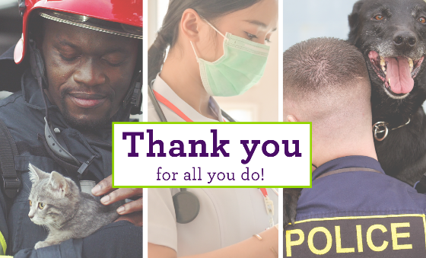

- If you use Vetstreet and need help obtaining log-in credentials or setting up the eblast, contact support@vetstreet.com
- If you use AllyDVM, this email communication and banner will be loaded into your dashboard and you can send the eblast when ready.
- If you use PetDesk and need help setting up this campaign, contact Kayla Hanono (kayla@petdesk.com) or Mackenzie Baird (mackenzie@petdesk.com)
- If you wish to send this communication directly from AVImark, instructions are attached.

- If you use any other client communication platform, use the email template above and contact your specific vendor for help, where needed.

2. WEBSITE MESSAGING
USING NVA PLATFORM? Email the Marketing Helpdesk (marketing@nva.com) to add the promotion the Promotions tab of your NVA website. Please provide the promotion details, including the expiration date and all exclusions. 3 coupons versions have been created for you. Please notify the Marketing Helpdesk which coupon you selected.
Firefighter & Kitten
Female Nurse/Doctor
Police Officer & Dog

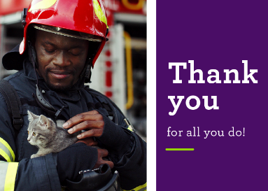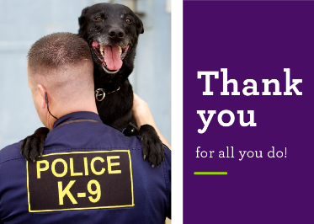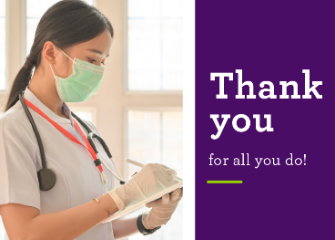

USING OUTSIDE VENDOR? Hospital manager to email third party vendor to add promotion to the website.

3. SOCIAL MEDIA
- To notify your clients that you offer a discount or promotion for first responders, use the below Facebook banners and social posts.
- We recommend pinning your Facebook post at the top of your timeline which makes it visible for 7 days. Step by step instructions how to utilize Facebook can be found below

- The banner and social images are located on https://www.gpconnect.nva.com website, First Responder and Medical Personnel Campaign.

FACEBOOK BANNERS: Upload one of the below 3 banners to your Facebook page.
Female Nurse/Doctor
Firefighter & Kitten
Police Officer & Dog

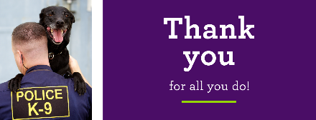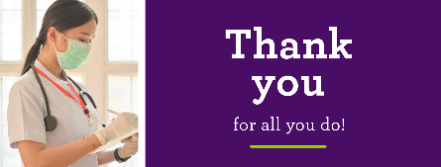

FACEBOOK POSTS USING 10% OFF EXAMS IN APRIL AND MAY 2020.
Note: To reach non clients on Facebook, boost your post and target 5 mile radius from your clinic, if budget allows. Contact your Marketing Business Partner for help, when needed.

Post #1:  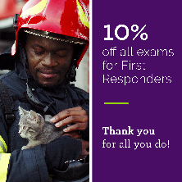 | Firefighter and kitten  - Post Copy: A special thanks to all our first responders who served our community during COVID -19. As a token of our appreciation we would like to offer 10% off all exams in April and May.  Call [ENTER TEL] or schedule an appointment online at [ENTER URL]. Offer expires 5.31.2020. Proof of service required at the time of check-in for your appointment.
Post # 2:  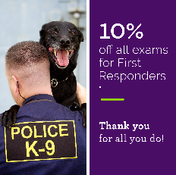 | Police officer and dog  - Post Copy: We would like to express our appreciation to the selfless men and women first responders by offering them 10% off all exams through 5.31.2020. Call [ENTER TEL] or schedule an appointment online at [ENTER URL]. Proof of service required at the time of check-in for your appointment.
Post # 3:  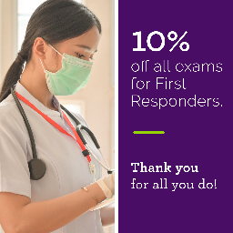 | Female nurse/doctor  - Post Copy: To all first responders, thank YOU for serving our community during the COVID-19 pandemic. We would like to offer our appreciation by offering you 10% off your pet’s wellness exams in April and May. Call [ENTER TEL] or schedule an appointment online at [ENTER URL]. Offer expires 5.31.2020. Proof of service required at the time of check-in for your appointment.

FACEBOOK POSTS USING HOSPITAL PROMOTION (I.E. XX% DISCOUNT OFF EXAMS, DROP OF EXAMS, EARLY/LATE APPOINTMENT, PAW PLANS, ETC.)
Note: To reach non clients on Facebook, boost your post and target 5 mile radius from your clinic, if budget allows. Contact your Marketing Business Partner for help, when needed.

Post #1:  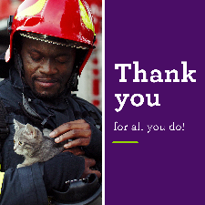 | Firefighter and kitten  - Post Copy: A special thanks to all our first responders who served our community during this pandemic. As a token of our appreciation we would like to offer [ENTER PROMOTION].  Call [ENTER TEL] or schedule an appointment online at [ENTER URL]. Offer expires 5.31.2020. Proof of service required at the time of check-in for your appointment.
Post # 2:  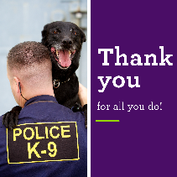 | Police officer and dog  - Post Copy: We would like to express our appreciation to the selfless men and women first responders by offering them [ENTER PROMOTION AND EXPIRATION DATE]. Call [ENTER TEL] or schedule an appointment online at [ENTER URL]. Proof of service required at the time of check-in for your appointment.
Post # 3:  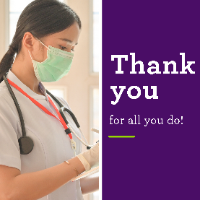 | Female nurse/doctor  - Post Copy: To all our local first responders, thank YOU for serving our community during this pandemic. We would like to offer our appreciation by offering you [ENTER PROMOTION]. Call [ENTER TEL] or schedule an appointment online at [ENTER URL]. Offer expires 5.31.2020. Proof of service required at the time of check-in for your appointment.

4. FLYERS

- Three generic versions of the flyer have been created to use in your clinic. A First Responder discount is called out without a specific %. These flyers can be found on Emergency.NVA.com, Site Leaders, Resources, General Practice, Marketing Tool Kit, GP Flyers.
Firefighter & Kitten
Police Officer & Dog
Female Nurse/Doctor

5. LOCAL MARKETING CHECKLIST

In addition to communicating the first responders promotion through email, social media, website and flyers, it is also recommended to also increase awareness of your offer in the community through Nextdoor App, local chamber of commerce, etc. Review the local marketing checklits below for additional ideas and reach out to your marketing business partner for questions.

