US Holiday Social Media Graphics

Overview:
We have compiled a list of the major US Holidays where your hospital location could see a change of hours. For each of these holidays, we have provided 6 different images for you to choose from to share on your social media profiles (3 dog graphics, and 3 cat graphics).

Graphics:
Images provided will include the name of the holiday, and will either state that you are:
- Open for business, but with adjusted hours.
- Closed for the day.
- Happy “Name of Holiday”!
  - (for use if you’d like to acknowledge the holiday, but have no change in hours and are open for business).
Post Copy:
Accompanying copy for the holiday graphic that you choose. Please edit as you see fit.
- Open for business, but with adjusted hours.

  - Happy [Name of Holiday]! This is a friendly reminder that our hospital will be open, but please see our adjusted hours: [List new hours for the holiday]. We will return to our regular business hours [tomorrow]. Thank you!

- Closed for the day

  - Happy [Name of Holiday]! This is a friendly reminder that our hospital will closed today for the holiday. We will open and return to our regular business hours [tomorrow]. Thank you!

- Happy “Name of Holiday”!

  - Happy [Name of Holiday]! This is a friendly reminder that we will remain open with our regular business hours today. Thank you!

Instructions:
For use, right-click and save on the desired graphic for the selected US Holiday. Upload and share to your social media sites with an accompanying post to inform your clients of any changes in business hours!

List of US Holidays:
- 4th of July [jump to section]
- Labor Day [jump to section]
- Columbus Day [jump to section]
- Veterans Day [jump to section]
- Thanksgiving [jump to section]
- Christmas Eve [jump to section]
- Christmas Day [jump to section]
- New Year’s Eve [jump to section]
- New Year’s Day [jump to section]
- Presidents’ Day [jump to section]
- Easter [jump to section]
- Memorial Day [jump to section]

Scroll down to view all holiday graphics!
4th of July | We are open, but please see our adjusted business hours:  We are closed for the day:  Happy 4th of July!

Labor Day | We are open, but please see our adjusted business hours:  We are closed for the day:  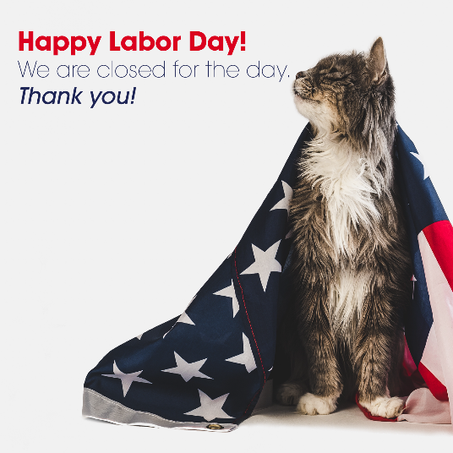  Happy Labor Day!

Columbus Day | We are open, but please see our adjusted business hours:  We are closed for the day:  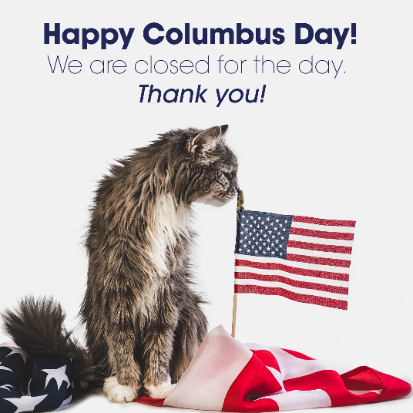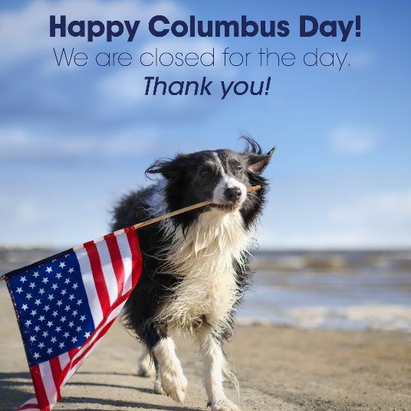  Happy Columbus Day!  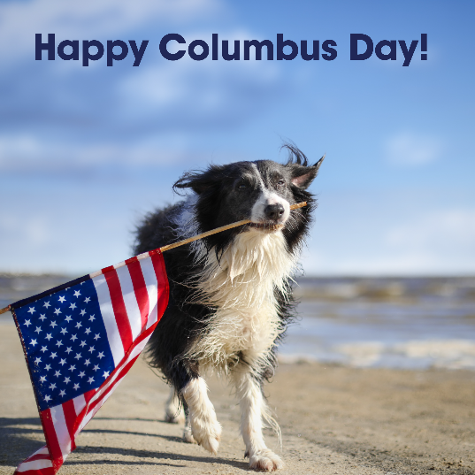

Veterans Day | We are open, but please see our adjusted business hours:  We are closed for the day:  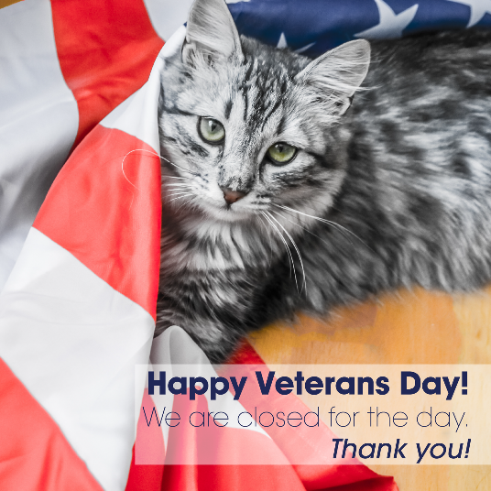  Happy Veterans Day!

Thanksgiving | We are open, but please see our adjusted business hours:  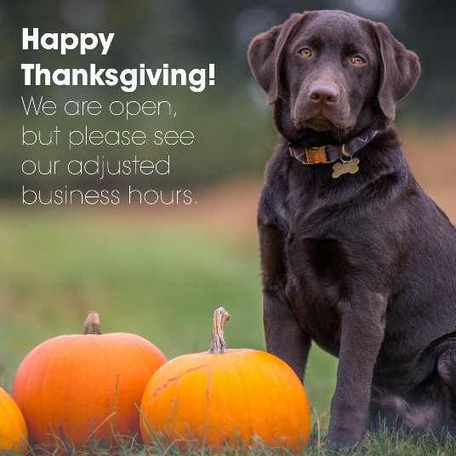  We are closed for the day:  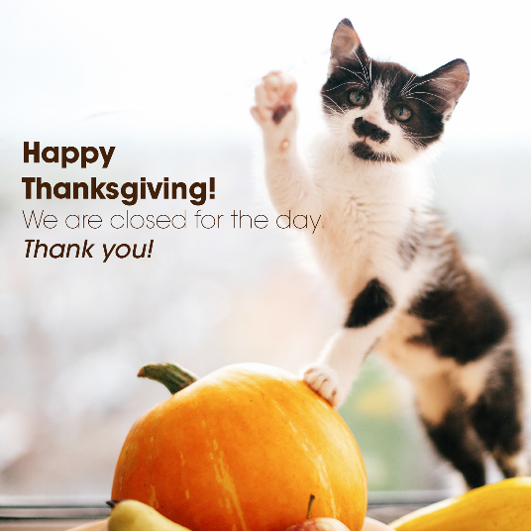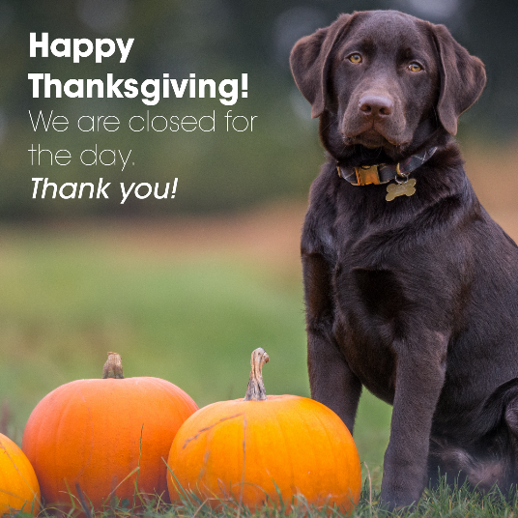  Happy Thanksgiving!  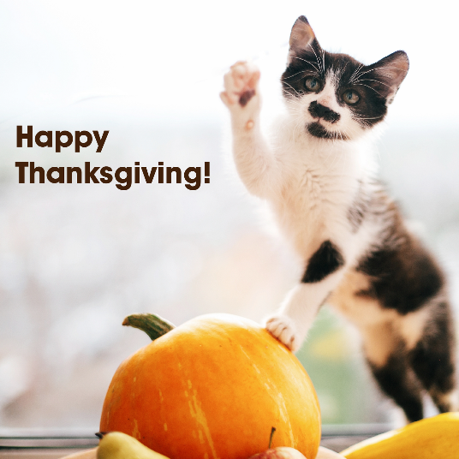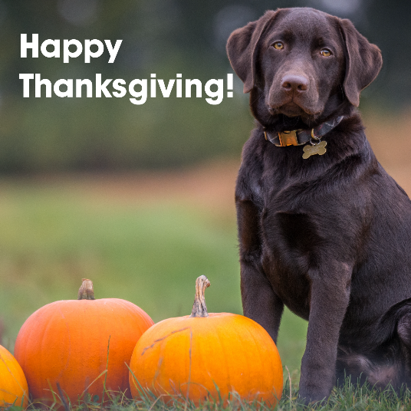

Christmas Eve | We are open, but please see our adjusted business hours:  We are closed for the day:  Merry Christmas Eve!

Christmas Day | We are open, but please see our adjusted business hours:  We are closed for the day:  Merry Christmas!

New Year’s Eve | We are open, but please see our adjusted business hours:  We are closed for the day:  Happy New Years Eve!

New Year’s Day | We are open, but please see our adjusted business hours:  We are closed for the day:  Happy New Years!

Presidents’ Day | We are open, but please see our adjusted business hours:  We are closed for the day:  Happy Presidents’ Day!

Easter | We are open, but please see our adjusted business hours:  We are closed for the day:  Happy Easter!

Memorial Day | We are open, but please see our adjusted business hours:  We are closed for the day:  Happy Memorial Day!:

