TELEMEDICINE SERVICES

WHEN YOU SHOULD USE THIS MARKETING TOOL KIT:

YES | You are open for telemedicine care
NO | Telemedicine is not available for emergency services

WHY THIS HELPS.
Communicate to clients you are open for telemedicine services.
Provides templates and tools to help hospitals continue serving clients
and generate revenue while ensuring the safety of staff and pet owners.

WHAT IS IN THIS TOOL KIT?

- Website messaging
- Social media posts and banners
- Email messaging template and banner
- On hold messaging
- Flyers

TELEMEDICINE SERVICES

1. WEBSITE MESSAGING
NVA PLATFORM: The following messaging can be added to your NVA powered website on your behalf.
- RECOMMENDED - Hero gallery on home page – will rotate with current home page pic.
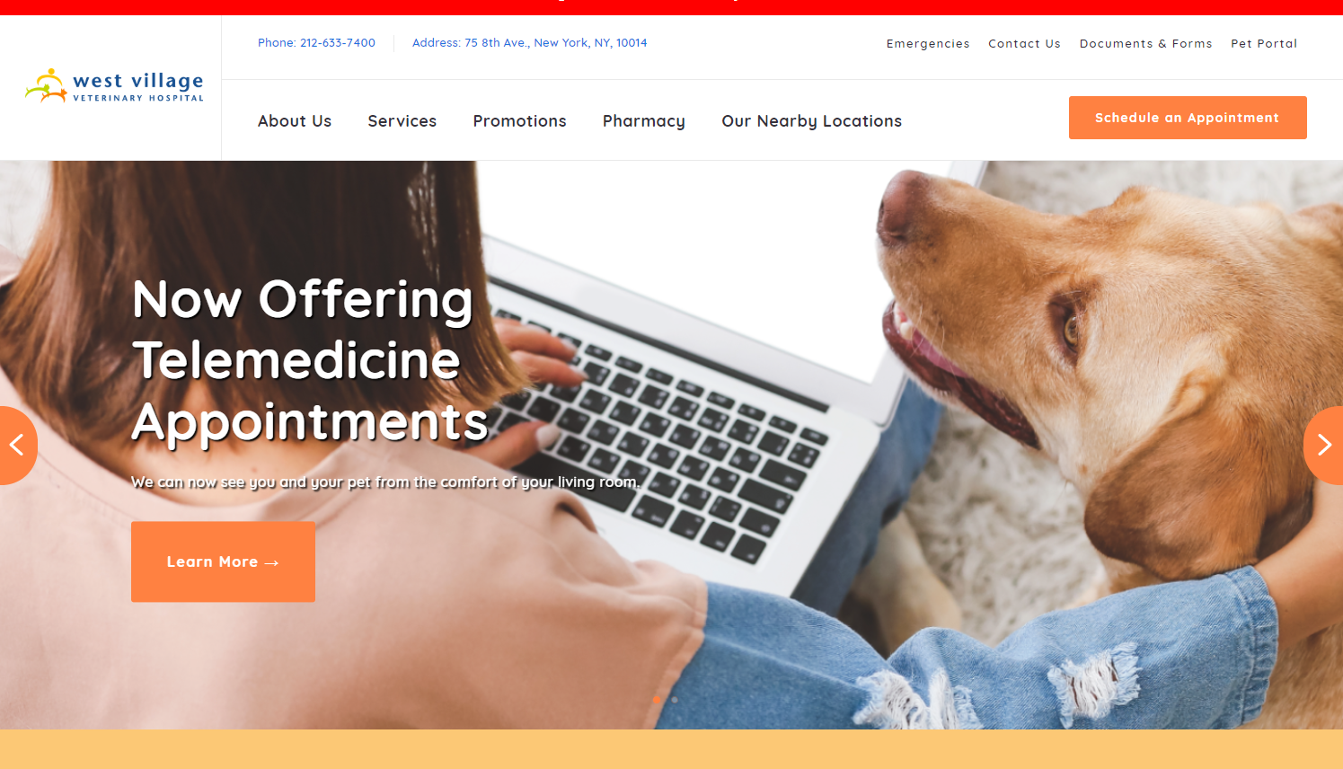

- EXCEPTION - Hero option – will rotate with current home page pic.
  - Message to read: ““Telemedicine available for those impacted by COVID-19”
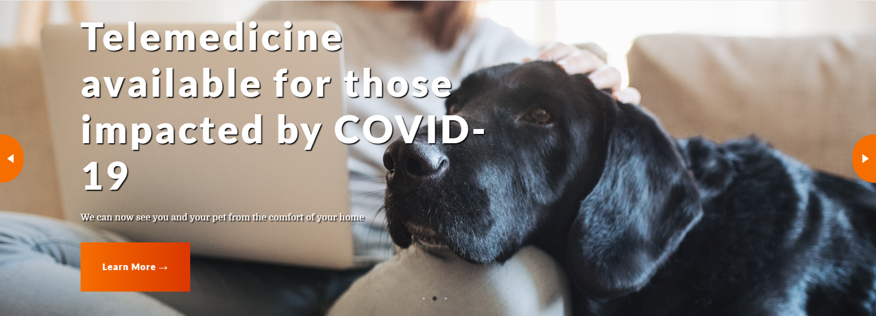

- Individual resource page:
  - Title: Telemedicine Services
  - Recommended Paragraph/CTA:
We now offer telemedicine consultations for select non-emergency services.

Through telemedicine consultation, you and your veterinarian will discuss your reason for scheduling the appointment and go over any questions/concerns you may have. As telemedicine consults are video calls, your doctor will be able to view and observe your pet for a better understanding of your pet’s heath.

Telemedicine is an excellent extension of hospital capabilities which we are excited to offer to our pet parents.

Please call to schedule a telemedicine appointment. Please note not every type of appointment is eligible to be handled via telemedicine.

  - EXCEPTION Paragraph/CTA:
We now offer telemedicine consultations for select non-emergency services for clients impacted by COVID-19.

Through telemedicine consultation, you and your veterinarian will discuss your reason for scheduling the appointment and go over any questions/concerns you may have. As telemedicine consults are video calls, your doctor will be able to view and observe your pet for a better understanding of your pet’s heath.

Telemedicine is an excellent extension of hospital capabilities which we are excited to offer to our pet parents in need.

Please call to schedule a telemedicine appointment. Please note not every type of appointment is eligible to be handled via telemedicine.

Not on NVA’s website platform? Hospital manager to send below messaging to outside vendor to add messaging to the website:
“Now offering telemedicine services! Call us for more information.”

2. SOCIAL MEDIA
- To notify your clients that you now offer telemedicince consultations, use one of the below Facebook photos and social posts.
- We recommend pinning your post at the top of your timeline which makes it visible for 7 days. Instructions how to upload a post and pin it can be found in the PDF below.
- The banner and social images are located on https://www.gpconnect.nva.com website, Telemedicine Campaign.

Step # 1: Facebook Banners
- To notify your clients that you now offer telemedicine services, use one of the below Facebook banners.
- The banner and social images are located on https://www.gpconnect.nva.com website, Telemedicine Campaign.
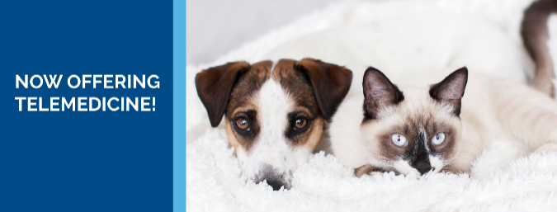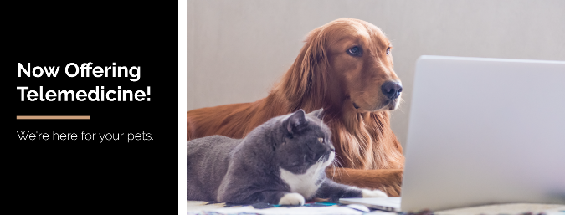
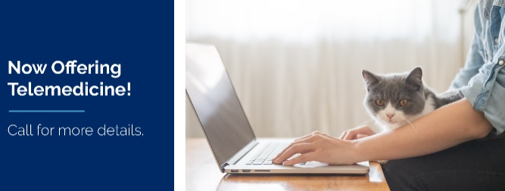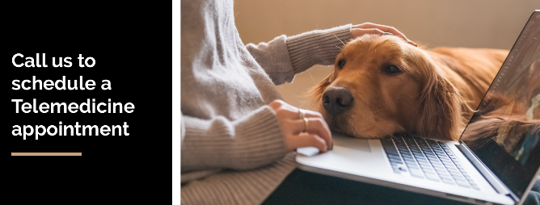

Step # 2: Facebook Post – Now Offering Telemedicine!
- “As the coronavirus (COVID-19) continues to develop and limit day-to-day activities, we are happy to announce that we now offer telemedicine consultations for select non-emergency services. Telemedicine helps us serve our clients while ensuring the safety of staff and pet owners. Please contact us at [INSERT PHONE NUMBER] to learn more or to schedule a telemedicine appointment!”
- Use one of the below images to upload along with your Facebook post.
  - The banner and social images are located on https://www.gpconnect.nva.com website, Telemedicine Campaign.

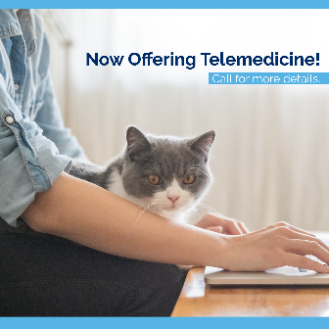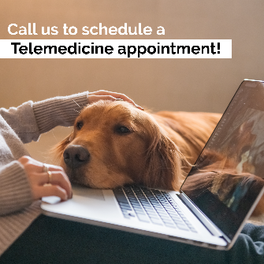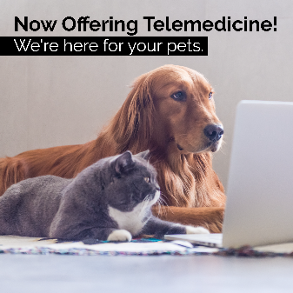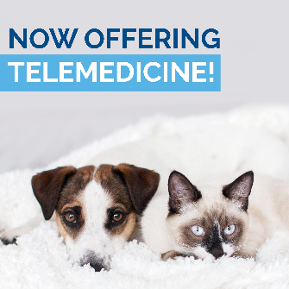
- We recommend pinning your post at the top of your timeline which makes it visible for 7 days. Instructions how to upload a post and pin it can be found in the PDF below.

3. EMAIL TEMPLATE

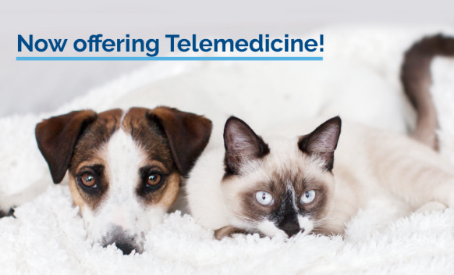

Dear Clients,

As the coronavirus (COVID-19) continues to develop and limit day-to-day activities, we are happy to announce that we now offer telemedicine consultations for select non-emergency services.

Through telemedicine consultation, you and your veterinarian will discuss your reason for scheduling the appointment and go over any questions/concerns you may have. As telemedicine consults are video calls, your doctor will be able to view and observe your pet for a better understanding of your pet’s heath.

Telemedicine is an excellent extension of hospital capabilities which we are excited to offer to our pet parents. As always, we are here for you during this time of social distancing.

Please contact us at [PHONE NUMBER] to learn more or to schedule a telemedicine appointment.

Warmly,
The team at [HOSPITAL NAME]

- Use one of the below email banners when sending eblast to existing customers. The files can be found on https://www.gpconnect.nva.com website, Telemedicine Campaign.

- If you use AllyDVM, this email communication and banners have been loaded into your dashboard already and you can send the communication when ready.
- If you use Vetstreet and you don’t have log-in access and wish to send an eblast, contact the below individuals to help you set up your campaign:
  - support@vetstreet.com
- If you use PetDesk and need help setting up a campaign, contact the below individuals:
  - Kayla Hanono (kayla@petdesk.com) or Mackenzie Baird (mackenzie@petdesk.com)
- If you use any other client communication platform, use the email template above and contact your specific vendor for help, where needed.

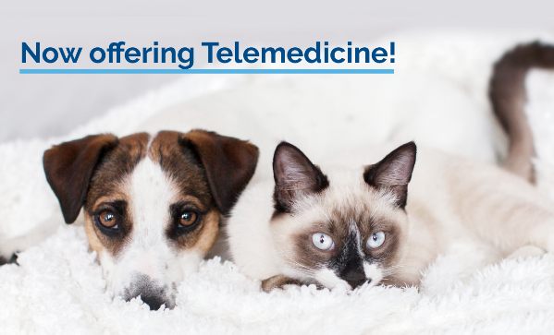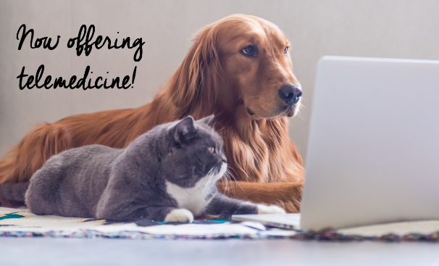

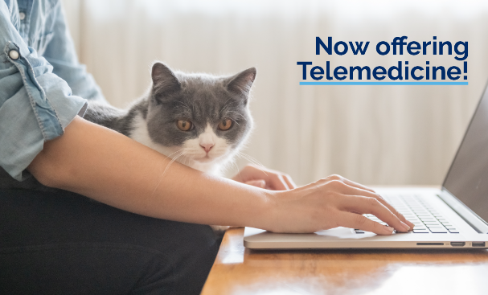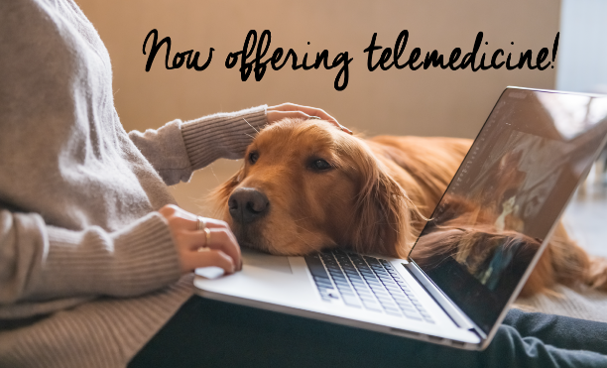

4. ON HOLD MESSAGING

Thank you for calling [HOSPITAL NAME]. Like everyone else, we are taking extra steps to ensure the health and safety of our clients, staff and of course, our patients. Therefore we are now offering telemedicine services. Through telemedicine video appointments, you’ll be able to discuss your pet’s health and our doctors will be able to view physical ailments your pet may have…all from the safety of your home. Our staff is here to answer any telemedicine questions you may have as well as scheduling appointments.

5. FLYERS

- Several flyer versions have been created to print and use in your clinic located on https://www.gpconnect.nva.com website, Telemedicine Campaign.

- Flyer copy:
“NOW OFFERING TELEMEDICINE! As the coronavirus (COVID-19) continues to develop and limit day-to-day activities, we are happy to announce that we now offer telemedicine consultations for select non-emergency services. Through telemedicine video appointments, you’ll be able to discuss your pet’s health and our doctors will be able to view physical ailments your pet may have…all from the safety of your home. Telemedicine is an excellent extension of hospital capabilities which we are excited to offer to our pet parents. Our staff is here to answer any telemedicine questions you may have as well as scheduling appointments.”

