COVID-19 Intra Team Management
Each site should make a determination as to whether they can provide a work environment for their teams that complies with their legal obligations to protect employees from known hazards, including COVID-19. Additional information can be found on the NVA emergency website.

The below risk levels guide should be utilized when determining if an employee of the hospital should be coming into the hospital for work on any given day.
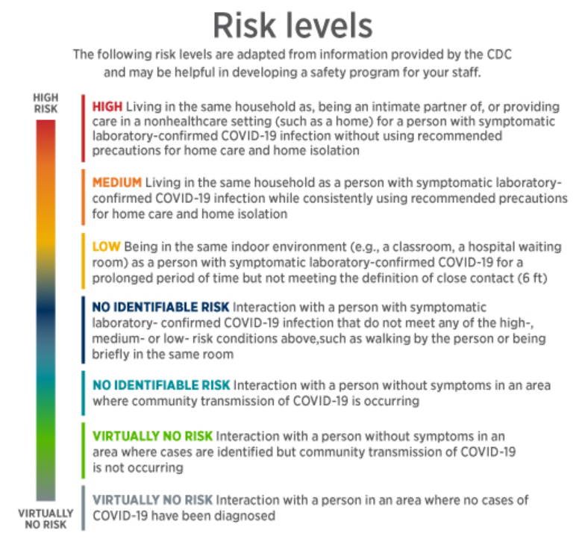
- If an employee is feeling unwell, they should stay at home in order to reduce possible exposure to the team

- Employees with High and Medium risk levels should stay home from work

- Employees in the range of Low to Virtually No Risk should come into the office ensuring to wear appropriate PPE (masks and gloves) as supply allows
  - If PPE supply is lacking, make use of makeshift masks such as bandanas

Physical Distancing:
All employees should take the necessary precautions to maintain 6 feet of distance from each other when possible and to wear appropriate PE when not possible.
- All employees should wear appropriate PPE and avoid direct contact with each other to ensure that risk is mitigated when adequate social distancing isn’t possible amongst employees
- Tape or other markers should be utilized in the work area to mark areas in the office where 6 feet social distancing can be achieved and to remind of boundaries so employees can maintain
appropriate distancing

Lunch:
- Employees should exit the hospital when eating lunch when possible
- Employees should not be eating lunch together unless maintaining 6 feet of distance. Even with 6 feet of distance, additional precaution should be taken as they will not be wearing appropriate PPE
- Re-apply PPE before entering the hospital

Team Meetings:
Team meetings should be hosted with at least 6 feet of distancing.
- If hospital space is limited, you can host meetings outside
- The best option for team meetings is to utilize Zoom for video / audio conferences

Use of Office Gear / Supplies:
Ensure the use of proper PPE when using office gear / supplies such as computers, medical equipment, cabinets, and payment processing systems.
- If possible, individuals should be allocated supplies for items such as pens, pencils, notebooks, etc. so that they do not need to be shared

Additional Notes:
- All employees should wash their hands diligently at the beginning of the day before applying PPE and at the end of the day after removing PPE
- If PPE supply is out, ensure to wash hands and use hand sanitizer throughout the day (after each appointment, before/after lunch, before / after using shared supplies / gear, etc.
- Post signs and reminders throughout the hospital to remind the team and any clients that come into the hospital of social distancing and handwashing expectations

COVID-19 Outdoor Client Interaction Management
Each hospital must take precautions related to outdoor client interaction in order to keep both employees and clients safe and slow the spread of COVID-19.
Please make sure to review the Curbside Service Best Practices Guide attached below to fully understand the outdoor service process.

When Offering Curbside Service:
- Ensure that all employees are wearing appropriate PPE and are trained on curbside protocols
- If utilizing an outdoor station, create tape/chalk marks on the ground to show clients how close they can stand to ensure proper 6 feet distancing
  - Hygiene partitions can be ordered for the outdoor station in order to decrease risk of infection
- Ensure proper 6 feet distancing from the client when retrieving the patient from their car. Ask the client to open the car door themselves and take the patient out of the car
  - Consider the same social distancing protocols when dropping the patient back off at the client’s car after the appointment / procedure

If Not Offering Curbside Service:
- Mark the ground from the entrance with tape/chalk in 6 foot increments to note proper social distancing for clients when waiting in line to enter the hospital
  - Ensure the first tape/chalk mark is 6 feet from the single-entry door
- Post signs outside of the hospital’s single-entry door to ensure that the queue takes note of the tape and reminds of the importance of social distancing
- Post additional signs to note the limited number of clients allowed in the hospital at once and to not come into the building until an employee retrieves them
- Once the hospital reaches capacity, customers should be admitted on a 1-out-1-in basis

Outdoor Euthanasia:
- The hospital can offer outdoor euthanasia if it has a private, calm, outdoor area
- Set up a sanitary work station and ensure proper distancing can be achieved by marking a waiting area for clients within view (using tape or chalk)
- If clients need to walk through the hospital to get to the private outdoor area, ensure indoor social distancing protocols are followed

