WE ARE OPEN
CURBSIDE DROP-OFF AND PICKUP MARKETING KIT

WHEN YOU SHOULD USE THIS TOOL KIT:

YES | You are open
YES | You transitioned to curbside drop-off and pickup ONLY
YES | You want to share COVID-19 guidelines
YES/NO | Your hours have changed
YES/NO | Your services have changed.

WHY THIS HELPS.
Communicate to clients you are open but offer curbside drop off and pickup only.
Plus standard COVID-19 policies including do not come if sick.

WHAT IS IN THIS TOOL KIT?

- Website banner messaging
- Social media posts
- Email language (template)
- On hold messaging
- Flyers

1. WEBSITE BANNER MESSAGING
NVA PLATFORM: The following banner messaging can be added to your NVA powered website on your behalf. Email the Marketing Helpdesk (marketing@nva.com) and request this message to be added on your NVA powered website.
We are open to provide care! In order to keep our staff and pet parents safe during the COVID-19 outbreak, we are implementing new procedures. We now offer curbside drop-off and pickup ONLY, limiting access to our lobby. Upon arrival to our clinic please remain in your car and call us. We will give you instructions on how to proceed at that time. If your pet needs medical care or if you need to pick up medication or food, please call us ahead of time for more details. If you experience flu like symptoms, please call us to reschedule or discuss alternative arrangements. Thank you!
OUTSIDE VENDOR: Hospital manager to send above communication to outside vendor to add messaging to the website:

2. SOCIAL MEDIA
- To notify your clients that you are open during the COVID-19 outbreak but have new admittance and checkout procedures, use the below Facebook banners and social posts.
- We recommend pinning your Facebook post at the top of your timeline which makes it visible for 7 days. Instructions how to upload a post and pin it can be found in the same location as the social posts and banners
- The banner, social images and instructions on how to pin your post are located Emergency.NVA.com, Site Leaders, Resources, General Practice, Marketing Tool Kit, Social Media

Option # 1: Facebook banner
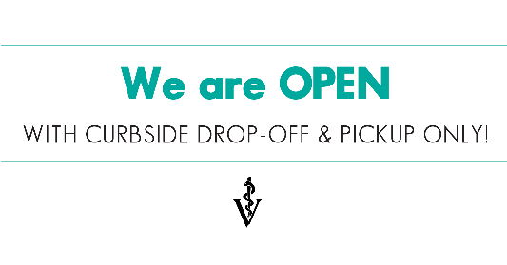

Option # 2: We are open with curbside drop-off and pickup only!
- Our clinic remains open during the COVID-19 outbreak! At this time we are limiting access to our lobby and implementing new drop-off and pickup procedures! Upon arrival at our practice please remain in your vehicle or outside of the hospital and call us. After receipt of the call our staff will either check you in as soon as possible from outside of the hospital, drop off the food or medication or provide you with additional details. If you are feeling ill or experiencing flu-like symptoms and have an upcoming appointment, please call us to reschedule or make accommodations with a friend of family member to bring in your pet at our clinic. Thank you for understanding!
- Use the below Facebook post located on Emergency.NVA.com , Site Leaders, Resources, General Practice, Marketing Tool Kit, Social Media
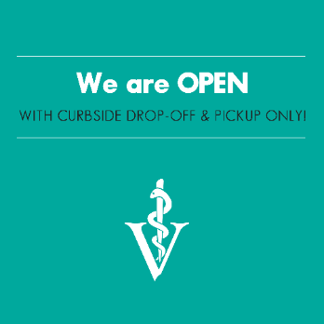

3. EMAIL TEMPLATE

Please review the below communication and edit information to make it relevant for your practice. If you do not offer online pharmacy, please remove the relevant text.

Subject line: CURBSIDE DROP-OFF AND PICK-UP INSTRUCTIONS!

Dear Clients,

The health and well-being of your pet is our top priority. As news of the coronavirus (COVID-19) in our community continues to develop, we are taking extra precautions to ensure the health and safety of humans within our facilities.

At this time, our clinic remains open and is operating under [MENTION IF YOUR CLINIC OPERATES UNDER REGULAR OR ADJUSTED BUSINESS]. However, we are restricting access to our lobby and adjusting our check-in and checkout procedures to keep our hospital staff and clients safe during this pandemic. We kindly ask that you follow the below steps for the safety of all:

- If you are healthy and have an appointment, upon arrival at our clinic, PLEASE REMAIN IN YOUR VEHICLE OR OUTSIDE THE CLINIC AND CALL US. After receipt of the call we will check in your pet as soon as possible from outside of the clinic. We kindly ask that you remain in your car during the entire time your pet is receiving medical care at our facility.
- If you need to pick up food or medication, PLEASE REMAIN IN YOUR VEHICLE OR OUTSIDE THE CLINIC AND CALL US. We will coordinate payment with you over the phone deliver the order to your car as soon as possible. Pet food and prescription refills can also be ordered ONLINE at [ENTER WEBSITE URL].
- If you are feeling ill or experiencing flu-like symptoms and have an upcoming non-life threatening appointment, we kindly ask that you call us to reschedule.
- If your pet requires urgent care or has a medical emergency, and you are ill, please make arrangements with a friend or family member to bring in the pet for you. We kindly ask that you call us ahead of time to make appropriate arrangements and follow above guidelines.

If you do not have a trusted friend, neighbor, or healthy family member to transport your pet, PLEASE CALL [ENTER HOSPITAL NUMBER] to make appropriate arrangements.

For all the above scenarios we will do our best to coordinate your visit from outside the hospital, including providing follow-up instructions and payment. Our goal is to continue to deliver essential services to our patients and keep pets and people safe!

For additional questions, please contact us at [EMAIL or phone.]
Thank you for your patience and cooperation.

The team at [HOSPITAL NAME]

- Use the below email banners when sending eblast to existing customers. The files can be found on Emergency.NVA.com, Site Leaders, Resources, General Practice, Marketing Tool Kit, Email Banners
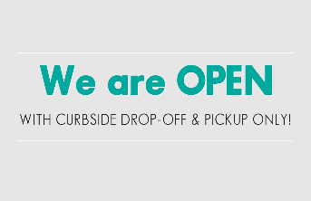

- If you use AllyDVM, this email communication and banner will be loaded into your dashboard and you can send the communication when ready.
- If you use PetDesk and need help setting up a campaign, contact the below individuals:
  - Kayla Hanono (kayla@petdesk.com) or Mackenzie Baird (mackenzie@petdesk.com)
- If you use any other client communication platform, use the email template above and contact your specific vendor for help, where needed.
- If you use Vetstreet, If you don’t have log-in access and wish to send an eblast, contact support@vetstreet.com

4. ON HOLD MESSAGING

Thank you for calling [HOSPITAL NAME]. Please listen carefully to this important COVID-19 message and procedures to follow.
- In the interest of keeping everyone healthy and safe, at this time we are restricting access to our lobby to clinic staff ONLY.
- If you have an appointment, upon arrival at our clinic, PLEASE REMAIN IN YOUR VEHICLE AND CALL [ENTER CLINIC TELEPHONE] TO SPEAK TO A MEMBER OF OUR TEAM UPON ARRIVAL. Upon receipt of the call a technician will come to your car to collect your pet. We kindly ask that you remain in your vehicle during the entire time your pet is in our care.
- If you need to pick up food or medication, PLEASE REMAIN IN YOUR VEHICLE OR OUTSIDE THE CLINIC AND CALL US. We will coordinate payment with you over the phone deliver the order to your car as soon as possible. Pet food and prescription refills can also be ordered ONLINE at [ENTER WEBSITE URL].
- If you are feeling ill or experiencing flu-like symptoms and your pet has an upcoming non-life or needs medical care, we kindly ask that you call us to discuss alternative options.
Thank you for your patience and cooperation during this time! We look forward to seeing you and your pet soon.
If you have called after hours and you have a medical emergency, please call [EMERGENCY HOSPITAL NAME] AT [HOSPITAL TELEPHONE NUMBER].

5. FLYER

- A generic flyer has been created to print and use in your clinic. This can be found on Emergency.NVA.com, Site Leaders, Resources, General Practice, Marketing Tool Kit, GP Flyers

