National Dog Day August 26th
Social Media Toolkit

WHY PARTICIPATE IN NATIONAL DOG DAY?
This content and tools will help you increase engagement on your social media pages by sharing fun and uplifting content around National Dog Day. National Dog Day was started to remind the public of the number of dogs that need to be rescued each year as well as honor those that save lives, keep us safe and bring comfort.

WHEN and WHY YOU SHOULD USE THIS TOOL KIT:
We recommend sharing content in the weeks leading up to Wednesday, August, 26th
- To encourage your social media followers to connect with you online by liking, commenting and sharing your posts
- To celebrate National Dog Day and dog heroes!
- To raise awareness for shelter/rescue dogs

HOW TO USE THIS TOOL KIT:
- NVA-Scheduled Posts
If opted-in to receive NVA’s scheduled content, select posts will be shared on your behalf on Thursday the 13th, 20th, and Wednesday the 26th. NO ACTION REQUIRED.

Want to opt in? Email Marketing@nva.com.

- Post and Share!
Check out the fun options for posts below and feel free to share on your social media sites as you’d like. Simply copy the provided post text, right-click and save the accompanying photo, and share to your social media pages. ACTION REQUIRED.

Need help posting? Email Marketing@nva.com.

NVA-Scheduled Posts
FYI ONLY – this will be posted on your behalf, if opted into NVA content. Not participating? Email Marketing@nva.com to get started.
Thurs 8/13  NVA-Scheduled Post  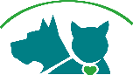 | Post Copy:  #NationalDogDay is less than two weeks away! Let’s create a social distancing pet parade on the way there! Post a photo of your dog in the car in the comment section below, and let’s see how long of a parade that we can make! #NationalDogDay  Post Photo:  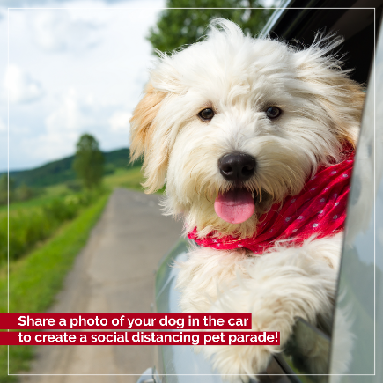
Thurs 8/20  NVA-Scheduled Post | Post Copy:  #NationalDogDay is coming up on the 26th and we’ll be spoiling all the dogs in our lives! What’s your favorite way to spoil your dog? Let us know in the comments.  - Treats  - Belly rubs  - Go for a walk / jog  - Dip in the water  - Snuggles  - All of the above!  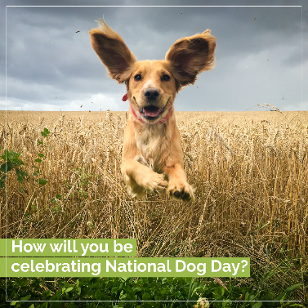  Post Photo:

Wed 8/26  NVA-Scheduled Post | Post Copy:  Happy #NationalDogDay! Our dogs provide love, support, happiness, and so much more each and every day. Today, we honor all of the wonderful dogs in our life as well as shelter and rescue dogs who are still waiting for their forever home. Happy National Dog Day! We Love you!  Post Photo:  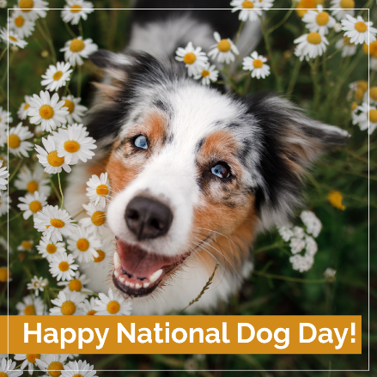

Post and Share!
Copy and paste any of the posts below, and right-click and save the accompanying photo for each post! Share to your Facebook and/or Instagram social media profiles.
Doggy Co-Worker

Post Copy:
Are you working from home? Do you have the cutest canine co-worker? Share a photo of them hard at work, or of them sleeping on the job in preparation for #NationalDogDay.

Post Photo:
Share Your Dog’s Story

Post Copy: Tell us how you and your furry friend (or friends 🐾) met! #NationalDogDay

Post Photo:

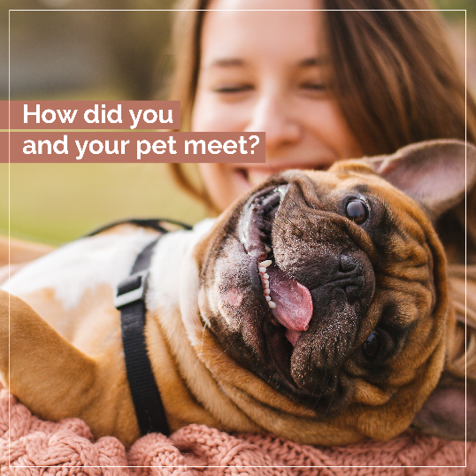

New Addition

Post Copy: Adopting a pet is life changing, and not just for you. ❤ #NationalDogDay #August26th

Post Photo:

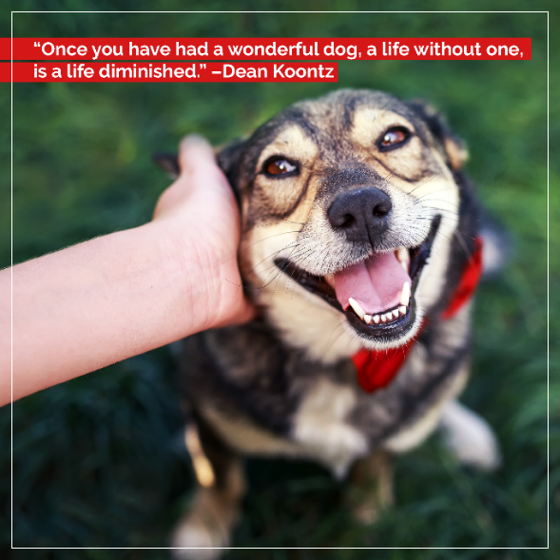
Recently Adopted

Post Copy: Have you recently adopted a puppy or a new dog? In honor of #NationalDogDay coming up, and to say thank you for providing a new dog with a forever home, share a photo of them in the comments. Let’s wish these families lots of luck and love on their new journey through life together! 🐾

Post Photo:

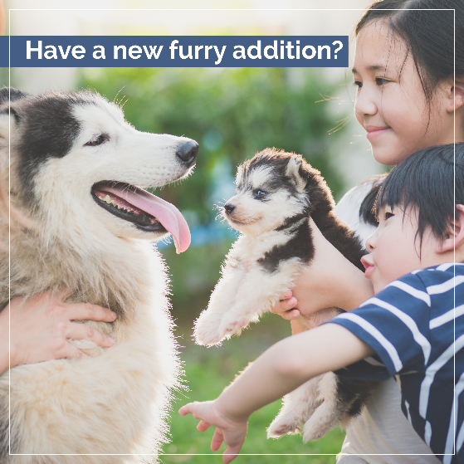
Social Distancing Photo Booth

Post Copy: Strike a pose! 📸 Share a photo of your dog looking his or her cutest. #Facebookneedsmoredogs #Welovecatstoo #NationalDogDay

Post Photo:

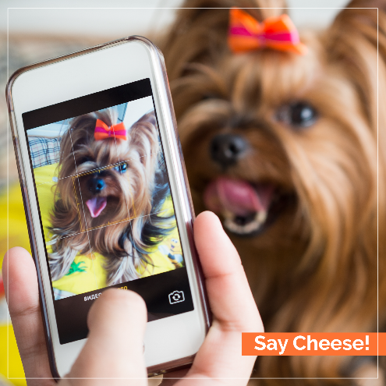
Dog’s Day

Post Copy: 🐶 🐾 #NationalDogDay #August26th

Post Photo:

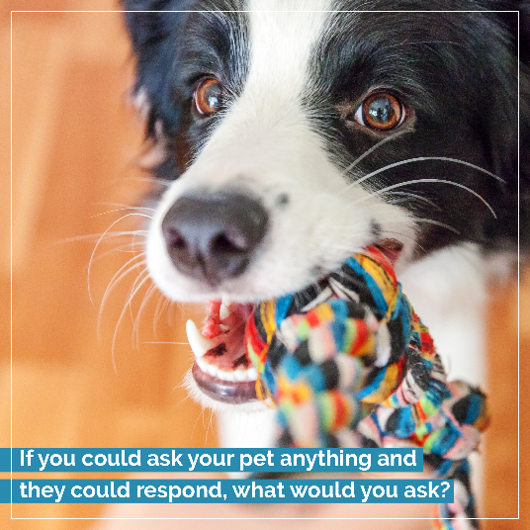

Describe Your Dog Using Emojis

Post Copy: Describe your dog using only emojis!

Post Photo:

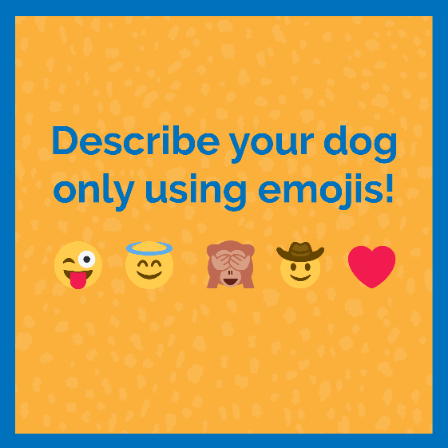
What is Your Dog’s True Name?

Post Copy: What is your dog’s true name? 😂 🐕

Post Photo:

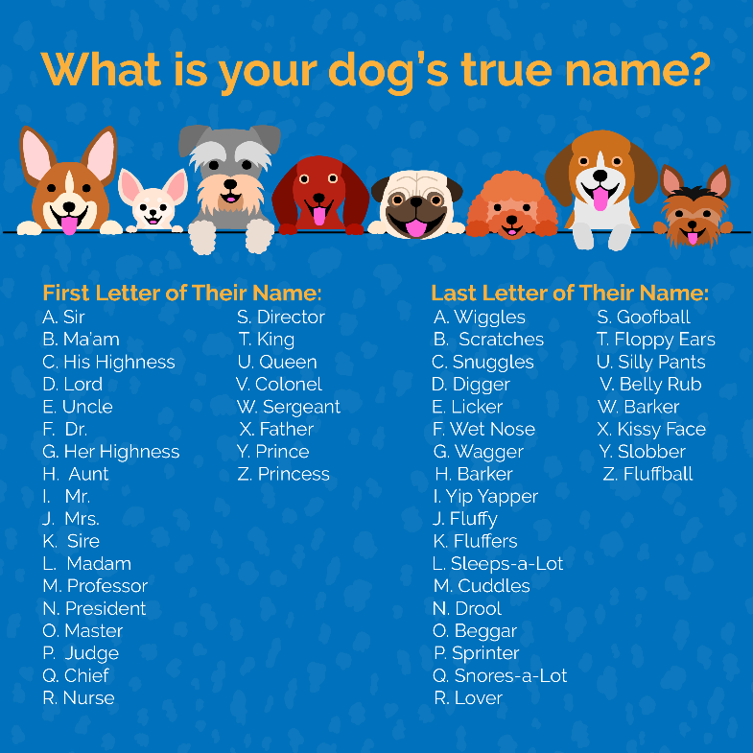

Share a Local Shelter Page

Post Copy: We want to shine a light on some amazing dogs that are waiting for their new forever home! Tag a shelter or rescue group you love in the comments. This August 26th, let’s create the best #NationalDogDay for all the adoptable pets!

Post Photo:

